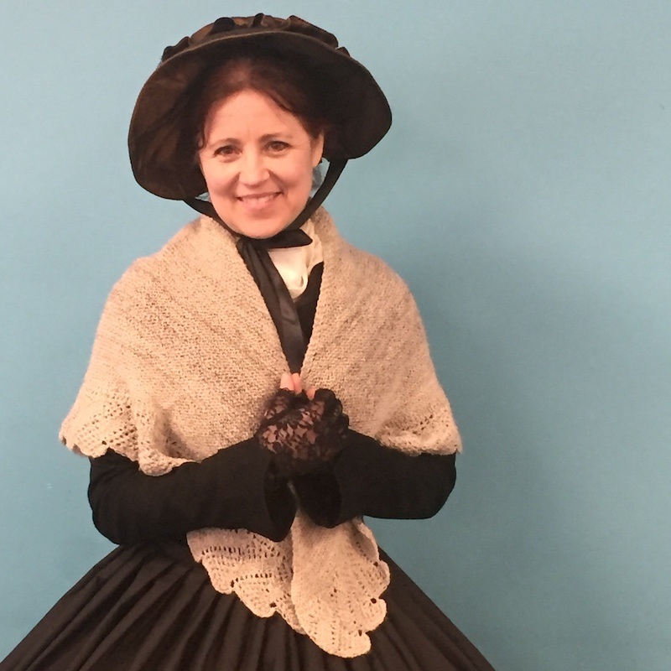

Dear Parents and Guardians,

On ______________________ your child will enjoy Young Audiences’ Frances Drake: Abolition and Women's Rights in 1850, a performance by living history performer Nancy Bell, brought to your school by ______________________. The local abolitionist and champion of women's suffrage steps out of the pages of history and into your classroom to tell her story. Included are tales of William Lloyd Garrison, the Underground Railroad, and the challenges of fighting for freedom for all as a woman with limited rights and power in a provincial community.

Talk about it! Ask your child about the program. You can use the following open-ended questions to start the conversation:

Tell me about the performance. What was the best part?
What surprised you? How did it make you feel?
What are you still wondering about? How can we learn more about that?

If your child enjoyed this program, we encourage you to reach out about how you can be involved in bringing the arts to schools. Please visit www.yamass.org to learn more about this and other Young Audiences’ Programs.

