
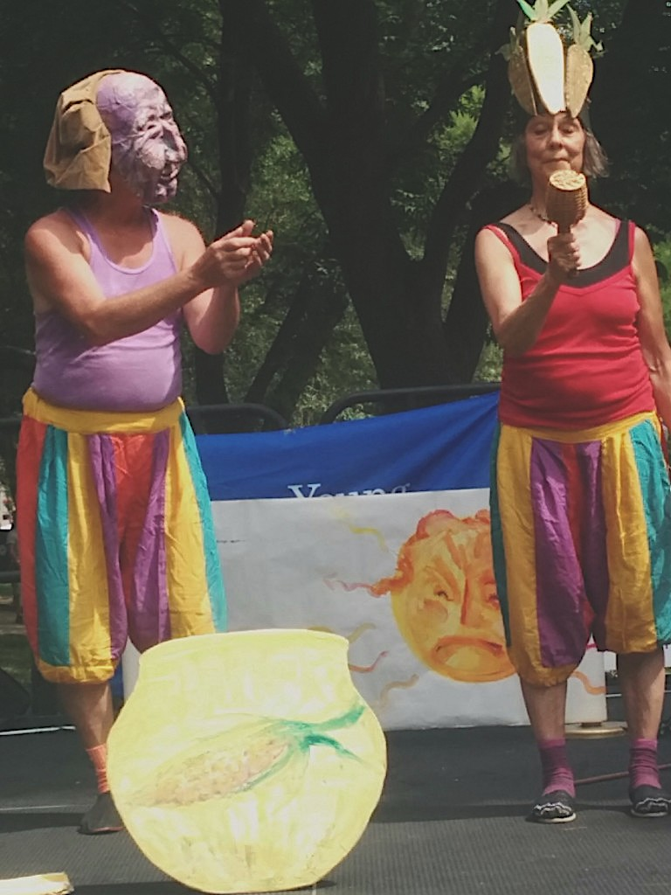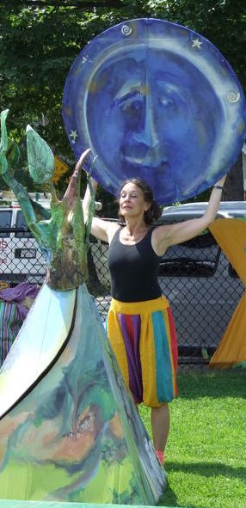

Dear Parents and Guardians,

On ______________________ your child will enjoy Young Audiences’ Sky Tales, a performance by theater troupe Mystic Paper Beasts, brought to your school by ____________.
Sky Tales presents a constellation of Native American Tales from seven different Native nations. Characters are distinguishable by the 25 hand-made masks worn by the two players. Sky Tales teaches students about myth, grounding them in some fundamental stories from Native American tradition and inspires them with a Do-It-Yourself approach to art-making.

Talk about it! Ask your child about the program. You can use the following open-ended questions to start the conversation:

Tell me about the performance. What was the best part?
What surprised you? How did it make you feel?
What are you still wondering about? How can we learn more about that?

If your child enjoyed this program, we encourage you to reach out about how you can be involved in bringing the arts to schools. Please visit www.yamass.org to learn more about this and other Young Audiences’ Programs.

