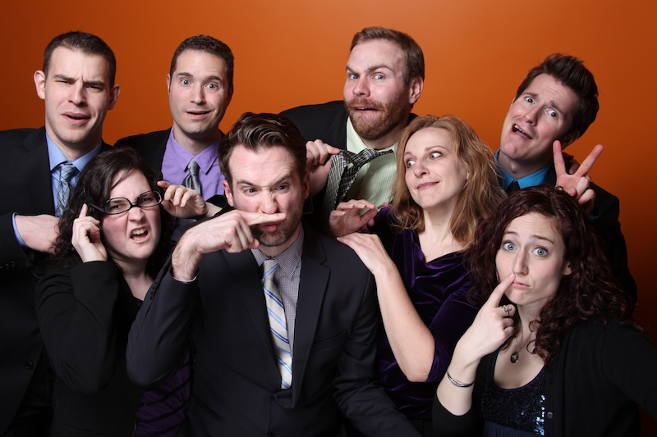

Dear Parents and Guardians,

On ______________________ your child will enjoy Young Audiences’ Your Totally Made Up Comedy Show, a performance by ImprovBoston, brought to your school by ______________________. Winner of the Nickelodeon award for Best Children’s Theater, ImprovBoston dishes out the laughs to audiences of all ages. This improv and music extravaganza is completely made up on the spot and highly interactive, featuring many opportunities for students to take the stage alongside the cast of professional improvisers. Never the same show twice, this show is creative, inspiring, engaging and hilarious entertainment that you child will be talking about for weeks to come.

Talk about it! Ask your child about the program. You can use the following open-ended questions to start the conversation:

Tell me about the performance. What was the best part?
What surprised you? How did it make you feel?
What are you still wondering about? How can we learn more about that?

If your child enjoyed this program, we encourage you to reach out about how you can be involved in bringing the arts to schools. Please visit www.yamass.org to learn more about this and other Young Audiences’ Programs.

