
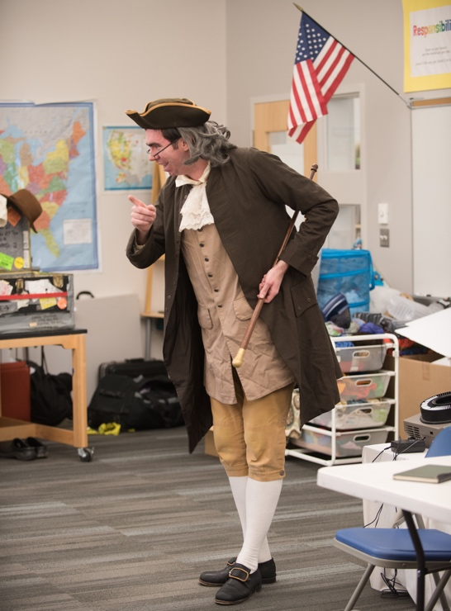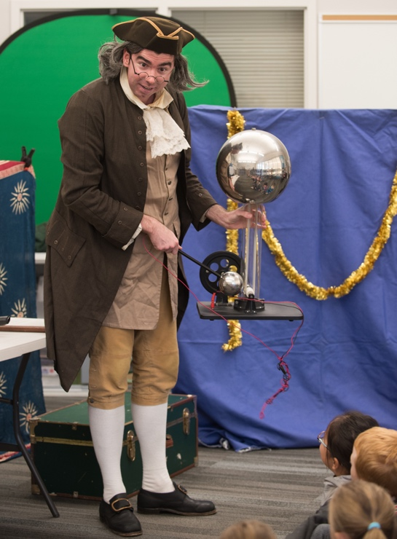

Dear Parents and Guardians,

On ______________________ your child will enjoy Young Audiences’ Benjamin Franklin – Statesman, Inventor, a performance by Historical Perspectives, brought to your school by ____________________. Meet the uniquely fascinating entrepreneur, inventor and founding father. With humor and drama, Ben shows his youthful days as a compulsive reader with a hungry mind, his tremendously successful rise through the printing trade, his scientific experiments and his triumphs as an inventor of items as diverse as bifocal glasses and swim fins. He demonstrates the spirit and industriousness that lead to American’s first circulating library and innovated postal service, and relives his elder days as a revolutionary who helps craft our founding documents. Ben’s story will ignite the natural curiosity of all students and challenge them to ask, “Why?” “What if?” and “What can I do to make a difference?”

Talk about it! Ask your child about the program. You can use the following open-ended questions to start the conversation:

Tell me about the performance. What was the best part?
What surprised you? How did it make you feel?
What are you still wondering about? How can we learn more about that?

If your child enjoyed this program, we encourage you to reach out about how you can be involved in bringing the arts to schools. Please visit www.yamass.org to learn more about this and other Young Audiences’ Programs.

