
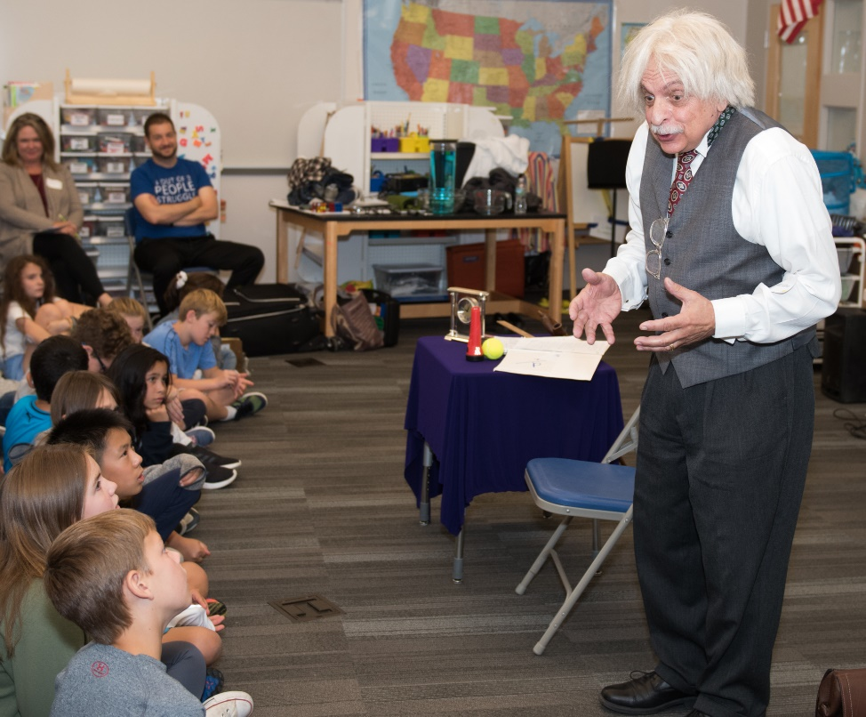

Dear Parents and Guardians,

On ______________________ your child will enjoy Young Audiences’ Albert Einstein: Relatively Speaking, a performance by actor George Capaccio, brought to your school by ______________________. Your child will meet the man whose name has become synonymous with genius. They will discover Einstein’s very human qualities and follow the trajectory of his life from a lowly patent clerk in a Swiss office to a world-renowned figure, learning of his insights into the nature of reality through interactive experiments.

Talk about it! Ask your child about the program. You can use the following open-ended questions to start the conversation:

Tell me about the performance. What was the best part?
What surprised you? How did it make you feel?
What are you still wondering about? How can we learn more about that?

If your child enjoyed this program, we encourage you to reach out about how you can be involved in bringing the arts to schools. Please visit www.yamass.org to learn more about this and other Young Audiences’ Programs.

