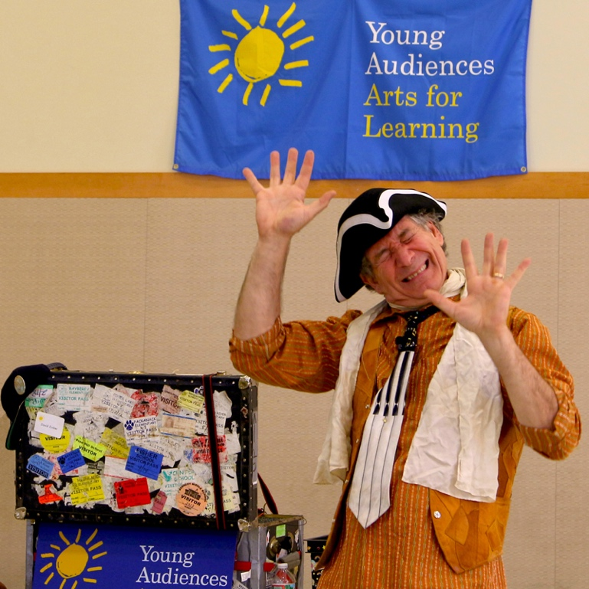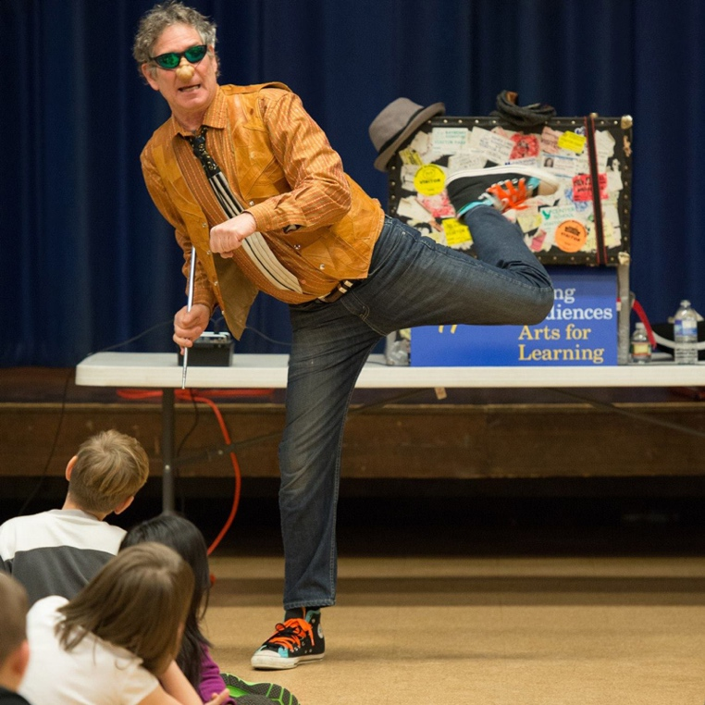

Dear Parents and Guardians,

On ______________________ your child will enjoy Young Audiences’ Poetry in Motion, a performance by actor and teacher David Zucker, brought to your school by ______________________. Poetry comes to life in David Zucker’s masterful performance of acting, mime, vocal gymnastics, humor, audience participation, and a trunk full of costumes, puppets, and props. David’s irresistible cast of characters, recreated from the poems by A.A. Milne, Lewis Carroll, Langston Hughes, Shel Silverstein, Edgar Allen Poe, and James Whitcomb Riley, are not to be missed.

Talk about it! Ask your child about the program. You can use the following open-ended questions to start the conversation:

Tell me about the performance. What was the best part?
What surprised you? How did it make you feel?
What are you still wondering about? How can we learn more about that?

If your child enjoyed this program, we encourage you to reach out about how you can be involved in bringing the arts to schools. Please visit www.yamass.org to learn more about this and other Young Audiences’ Programs.

