
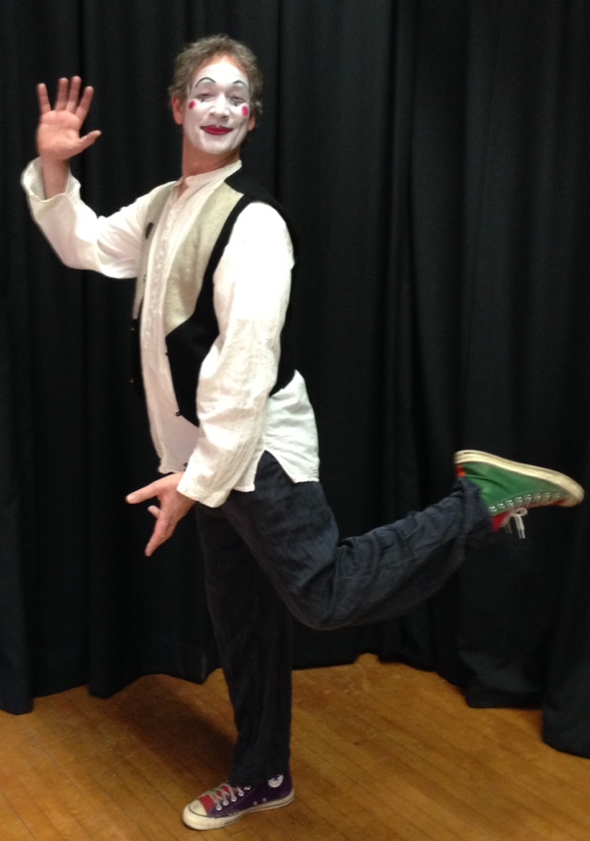

Dear Parents and Guardians,

On ______________________ your child will enjoy Young Audiences’ Odyssey of the Mime, a performance by mime, actor and teacher David Zucker, brought to your school by _______________. Mime knows no barriers of language or culture. David Zucker’s internationally recognized improvisational performance draws students into his world, where they become eager participants rather than mere observers. With a cornucopia of imaginary props, walls arise from nowhere, ladders leap to impossible heights, fish can fly, birds can swim, and anything is likely to happen!

Talk about it! Ask your child about the program. You can use the following open-ended questions to start the conversation:

Tell me about the performance. What was the best part?
What surprised you? How did it make you feel?
What are you still wondering about? How can we learn more about that?

If your child enjoyed this program, we encourage you to reach out about how you can be involved in bringing the arts to schools. Please visit www.yamass.org to learn more about this and other Young Audiences’ Programs.

