
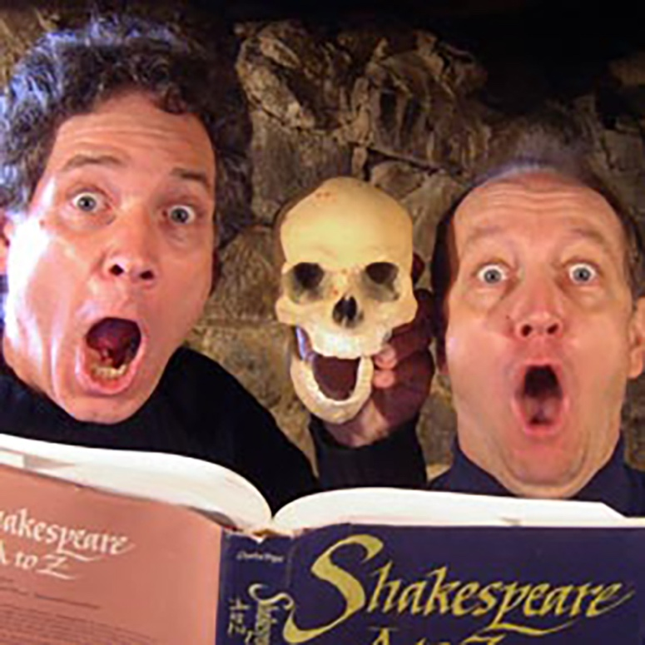

Dear Parents and Guardians,

On ______________________ your child will enjoy Young Audiences’ Shakespeare Guyz, a performance by actors David Zucker and Richard McElvain, brought to your school by _____________. Through humor, costumed sword-fights, Elizabethan insults, and complete audience involvement, Richard McElvain and David Zucker bring The Bard’s genius to life. From Hamlet’s grief over Yoric’s skull to the balcony scene from Romeo and Juliet to an over-the-top version of Pyramus and Thisbe, David and Richard ignite an excitement for The Bard in the classroom. The Shakespeare Guyz challenge students to make personal connections with Shakespeare’s themes and realize the power of Shakespeare’s legacy.

Talk about it! Ask your child about the program. You can use the following open-ended questions to start the conversation:

Tell me about the performance. What was the best part?
What surprised you? How did it make you feel?
What are you still wondering about? How can we learn more about that?

If your child enjoyed this program, we encourage you to reach out about how you can be involved in bringing the arts to schools. Please visit www.yamass.org to learn more about this and other Young Audiences’ Programs.

