
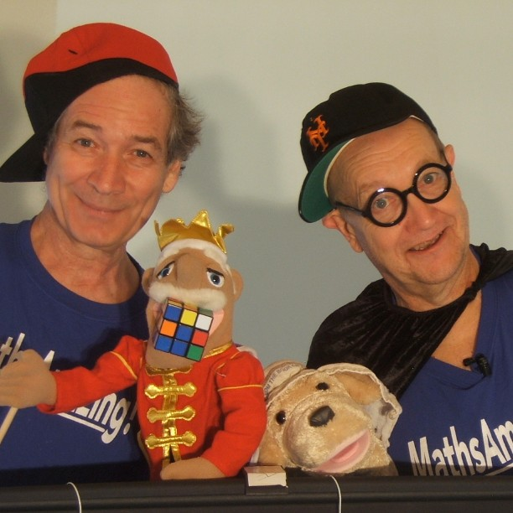

Dear Parents and Guardians,

On ______________________ your child will enjoy Young Audiences’ MathsAmazing!, a performance by actors David Zucker and Richard McElvain, brought to your school by ______________________. In this witty and surprise-filled theater piece in the tradition of Shakespeare Guyz and MythMasters, David and Richard invite their audience to dive into this sometimes intimidating subject as they might a soccer or video game. Using multi-media, puppetry, fun costumes, music and audience participation, they take students back through some of the great historical moments of mathematical discovery!

Talk about it! Ask your child about the program. You can use the following open-ended questions to start the conversation:

Tell me about the performance. What was the best part?
What surprised you? How did it make you feel?
What are you still wondering about? How can we learn more about that?

If your child enjoyed this program, we encourage you to reach out about how you can be involved in bringing the arts to schools. Please visit www.yamass.org to learn more about this and other Young Audiences’ Programs.

