
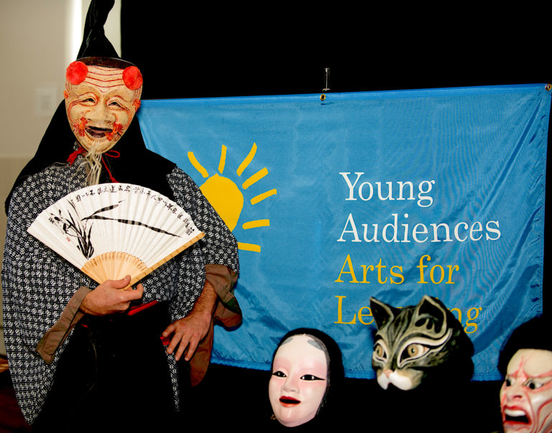

Dear Parents and Guardians,

On ______________________ your child will enjoy Young Audiences’ Cat Mountain, a performance by mask makers and performers Behind the Mask, brought to your school by ______________________. A Japanese folk tale comes to life in this theater performance with original music, masks, and traditional Japanese songs. Listen and experience the story of Sho, a servant girl who journeys to Cat Mountain where she hopes to find her cat and her own freedom.
Talk about it! Ask your child about the program. You can use the following open-ended questions to start the conversation:

Tell me about the performance. What was the best part?
What surprised you? How did it make you feel?
What are you still wondering about? How can we learn more about that?

If your child enjoyed this program, we encourage you to reach out about how you can be involved in bringing the arts to schools. Please visit www.yamass.org to learn more about this and other Young Audiences’ Programs.

