
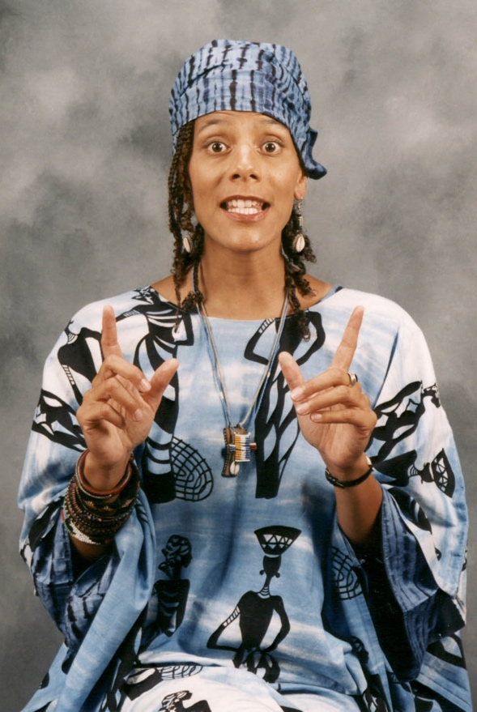
Dear Parents and Guardians,

On ______________________ your child will enjoy Young Audiences’ The Right To…Liberty, a performance by storyteller Valerie Tutson, brought to your school by ______________________. During the colonial period and the time of the American Revolution, freedom was on the minds of all people, including those held in captivity or on the margins in the free Black communities. There were many Black people who wanted to make sure that the revolutionary ideals of the rights to life, liberty, and the pursuit of happiness would become reality for themselves, their community, and their children. Storyteller Valerie Tutson recounts significant moments from this moment in our national history.

Talk about it! Ask your child about the program. You can use the following open-ended questions to start the conversation:

Tell me about the performance. What was the best part?
What surprised you? How did it make you feel?
What are you still wondering about? How can we learn more about that?

If your child enjoyed this program, we encourage you to reach out about how you can be involved in bringing the arts to schools. Please visit www.yamass.org to learn more about this and other Young Audiences’ Programs.

