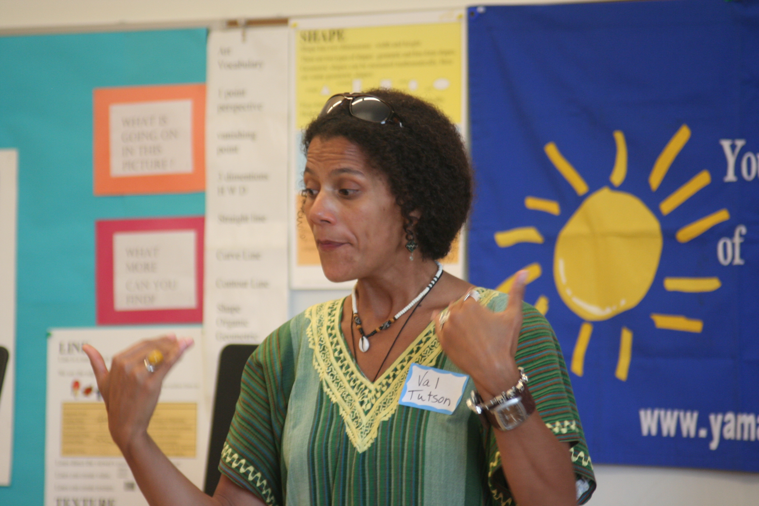

Dear Parents and Guardians,

On ______________________ your child will enjoy Young Audiences’ Tales from African Traditions, a performance by storyteller Valerie Tutson, brought to your school by ______________________. Drawing from her own travels, Valerie brings to life an assortment of myths, folktales and historical accounts from the African continent and the African Diaspora, showing students the beauty, humor and wisdom of the diverse and ancient cultures of Africa through stories. We encourage you to extend the learning at home.

Talk about it! Ask your child about the program. You can use the following open-ended questions to start the conversation:

Tell me about the performance. What was the best part?
What surprised you? How did it make you feel?
What are you still wondering about? How can we learn more about that?

If your child enjoyed this program, we encourage you to reach out about how you can be involved in bringing the arts to schools. Please visit www.yamass.org to learn more about this and other Young Audiences’ Programs.

