
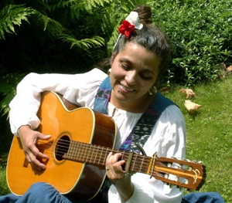

Dear Parents and Guardians,

On ______________________ your child will enjoy Young Audiences’ Recuerdo Ser Simpatico (Remember to be Nice), a performance by storyteller Robin Pease, brought to your school by ______________________. Robin Pease tells the story of a mean turtle who learns the value of friendship and remembers to be nice. During the program, students participate in Spanish language, song, and learn about animals and places in Costa Rica.

Talk about it! Ask your child about the program. You can use the following open-ended questions to start the conversation:

Tell me about the performance. What was the best part?
What surprised you? How did it make you feel?
What are you still wondering about? How can we learn more about that?

If your child enjoyed this program, we encourage you to reach out about how you can be involved in bringing the arts to schools. Please visit www.yamass.org to learn more about this and other Young Audiences’ Programs.

