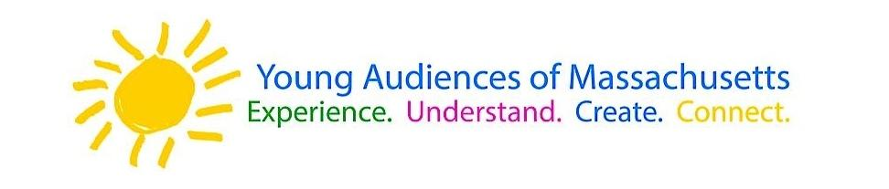
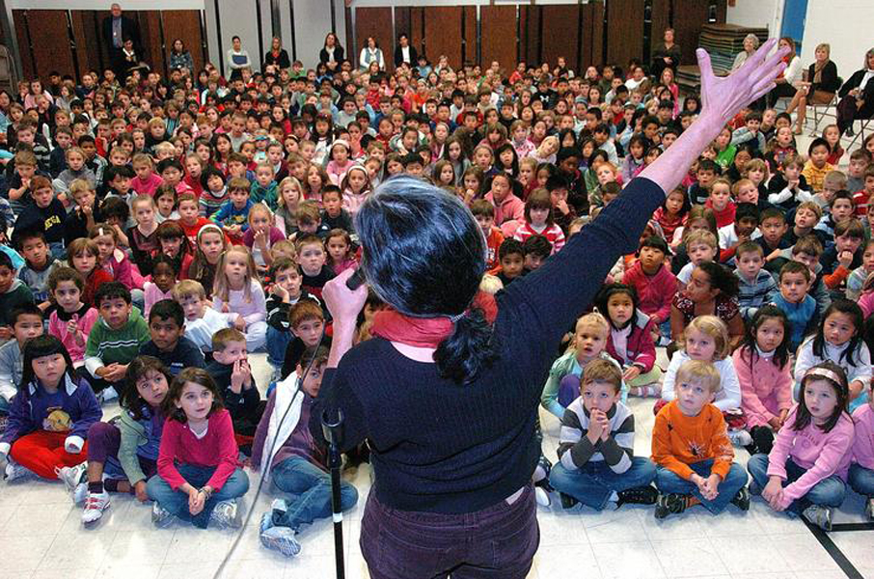

Dear Parents and Guardians,

On ______________________ your child will enjoy Young Audiences’ Storytelling: Your Program, a performance by storyteller Norah Dooley, brought to your school by ______________________.
Norah puts her extensive trove of stories, folktales, fables, and songs to work for your school by crafting a unique storytelling program centered on the theme or culture of your choice – and linking it directly in with your curriculum. Possible themes include Irish stories, Italian stories, Caribbean stories, bullying, nonviolent conflict resolution, tricksters, female heroines, and more!

Talk about it! Ask your child about the program. You can use the following open-ended questions to start the conversation:

Tell me about the performance. What was the best part?
What surprised you? How did it make you feel?
What are you still wondering about? How can we learn more about that?

If your child enjoyed this program, we encourage you to reach out about how you can be involved in bringing the arts to schools. Please visit www.yamass.org to learn more about this and other Young Audiences’ Programs.

