

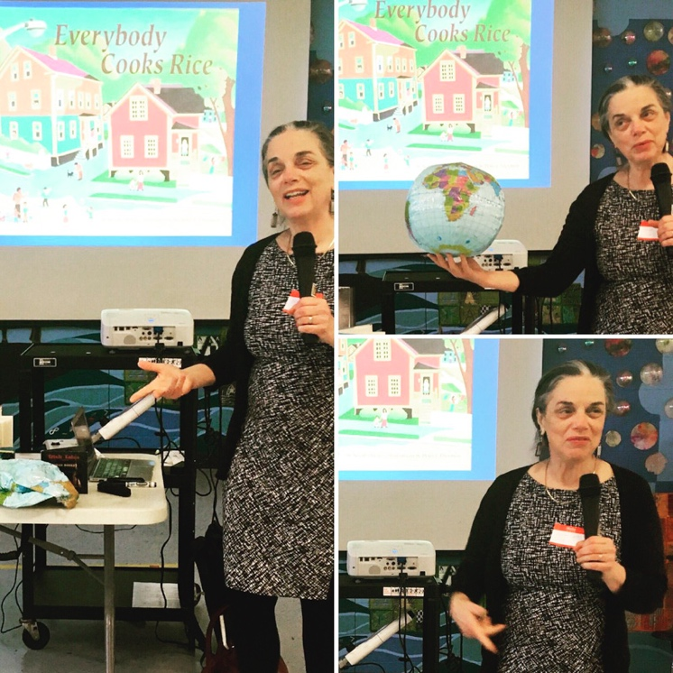

Dear Parents and Guardians,

On ______________________ your child will enjoy Young Audiences’ Stories from the Neighbors, a performance by storyteller Norah Dooley, brought to your school by ______________________.
In this multicultural storytelling program, folk tales and fables include stories centered around social justice, immigration, tolerance, and diversity. Stories from the Neighbors embraces the cultural diversity that is found within our communities and shows students how much they can learn from people in their own neighborhoods. Students compose sounds to the stories shared, and the assembly culminates with a storytelling game in which the students find and tell their own stories, discovering how their voice is part of the greater communal voice!

Talk about it! Ask your child about the program. You can use the following open-ended questions to start the conversation:

Tell me about the performance. What was the best part?
What surprised you? How did it make you feel?
What are you still wondering about? How can we learn more about that?

If your child enjoyed this program, we encourage you to reach out about how you can be involved in bringing the arts to schools. Please visit www.yamass.org to learn more about this and other Young Audiences’ Programs.

