
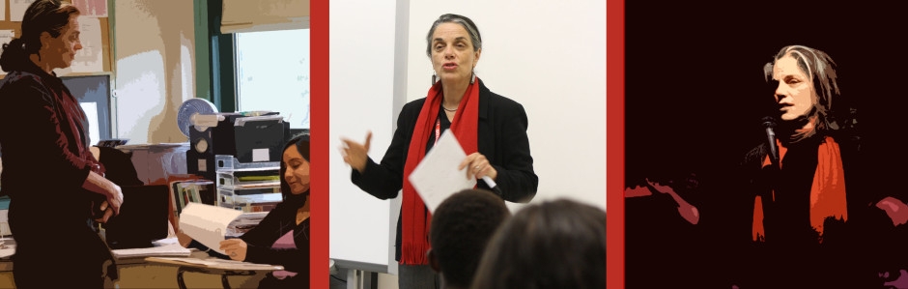
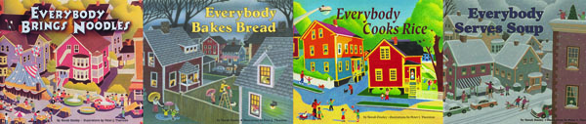

Dear Parents and Guardians,

On ______________________ your child will enjoy Young Audiences’ Everyone Has a Story: From Idea to Book, a performance by storyteller Norah Dooley, brought to your school by ______________.
Drawing on her life as a writer, her passion for storytelling and her defining sense of humor, Norah leads students through the process of how, with imagination and craft, life becomes a story and a story becomes a book. This highly interactive presentation includes stories both true and fantastic, story mapping exercises and games.

Talk about it! Ask your child about the program. You can use the following open-ended questions to start the conversation:

Tell me about the performance. What was the best part?
What surprised you? How did it make you feel?
What are you still wondering about? How can we learn more about that?

If your child enjoyed this program, we encourage you to reach out about how you can be involved in bringing the arts to schools. Please visit www.yamass.org to learn more about this and other Young Audiences’ Programs.

