
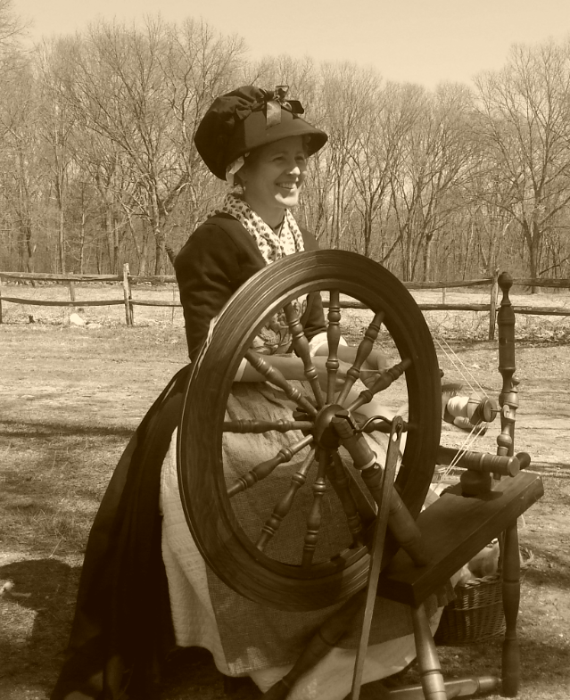

Dear Parents and Guardians,

On ______________________ your child will enjoy Young Audiences’ Spinning History: Heroines on the Home Front, a performance by storyteller Nancy Bell, brought to your school by ______________________. Her “Spinning History” program is a visual arts and women’s history performance about the role the art of spinning played in the American Revolution. Dressed in carefully researched, hand-sewn, historically accurate clothing, she demonstrates three kinds of spinning from “the Great Wheel” to the “drop spindle” and sings propaganda songs, used during the Colonial Revolution, to entice young female rebels to learn to spin.

Talk about it! Ask your child about the program. You can use the following open-ended questions to start the conversation:

Tell me about the performance. What was the best part?
What surprised you? How did it make you feel?
What are you still wondering about? How can we learn more about that?

If your child enjoyed this program, we encourage you to reach out about how you can be involved in bringing the arts to schools. Please visit www.yamass.org to learn more about this and other Young Audiences’ Programs.

