
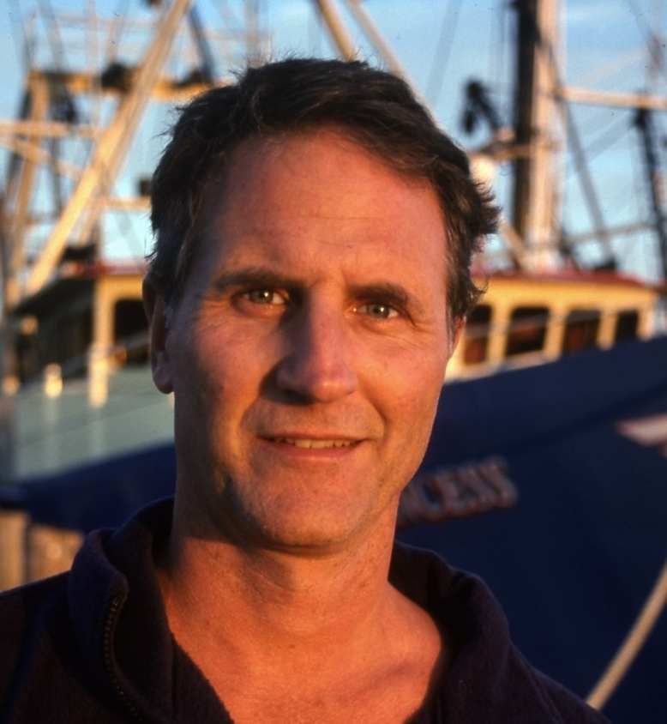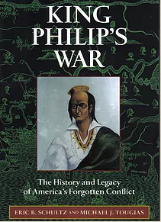

Dear Parents and Guardians,

On ______________________ your child will enjoy Young Audiences’ Massachusetts, a performance by NY Times Bestselling Author Michael Tougias, brought to your school by _____________________. Drawing from the research in his book, Tougias discusses the causes, the battles, and the aftermath of America’s first war between colonists and native people. He illustrates the topic with dramatic photography slides and then discussed the research and writing process behind his two books on the subject, one, a history of the war, and the other, a historical novel.

Talk about it! Ask your child about the program. You can use the following open-ended questions to start the conversation:

Tell me about the performance. What was the best part?
What surprised you? How did it make you feel?
What are you still wondering about? How can we learn more about that?

If your child enjoyed this program, we encourage you to reach out about how you can be involved in bringing the arts to schools. Please visit www.yamass.org to learn more about this and other Young Audiences’ Programs.

