
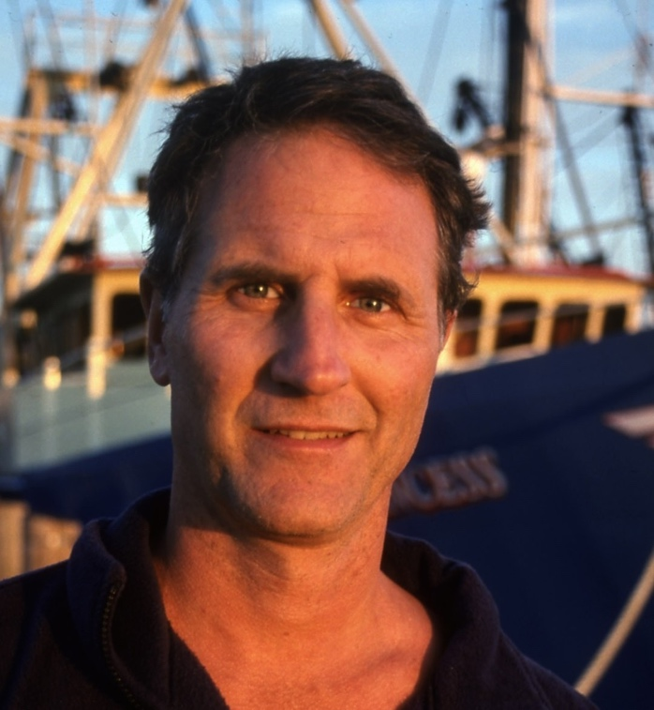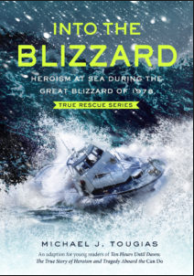

Dear Parents and Guardians,

On ______________________ your child will enjoy Young Audiences’ Into The Blizzard: Heroism at Sea During the Great Blizzard of 1978, a performance by NY Times Bestselling Author Michael Tougias, brought to your school by ______________________. During the height of the blizzard of 1978, the pilot boat Can Do, set out from Gloucester, MA with five men onboard, to assist a lost Coast Guard boat and an oil tanker in a Mayday situation. Using dramatic photography slides, Tougias tells the story of what happened on that awful night when the seas were producing monstrous waves of 40 feet and the wind was screaming at 115 miles per hour. After telling the story, Tougias engages students in a discussion of his research and writing process for the book and offers tips for their own projects.

Talk about it! Ask your child about the program. You can use the following open-ended questions to start the conversation:

Tell me about the performance. What was the best part?
What surprised you? How did it make you feel?
What are you still wondering about? How can we learn more about that?

If your child enjoyed this program, we encourage you to reach out about how you can be involved in bringing the arts to schools. Please visit www.yamass.org to learn more about this and other Young Audiences’ Programs.

