
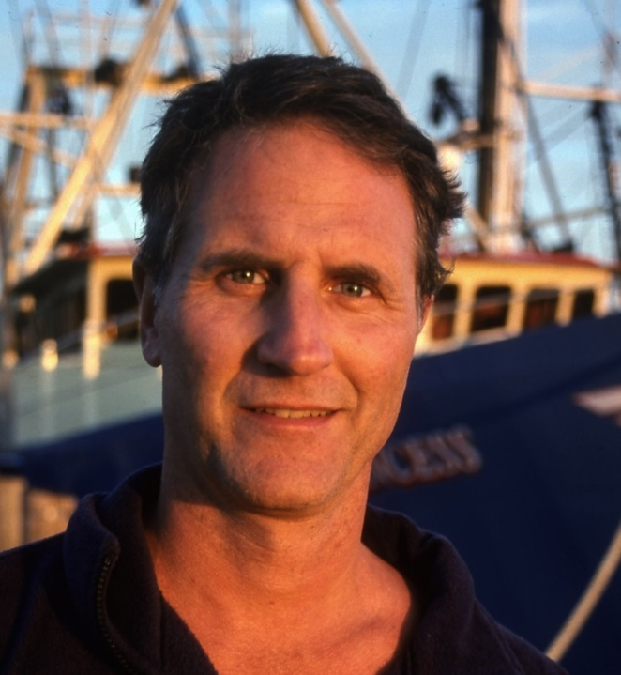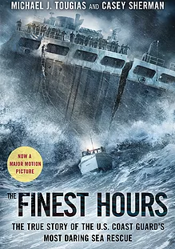

Dear Parents and Guardians,

On ______________________ your child will enjoy Young Audiences’ The Finest Hours: The True Story of the Coast Guard’s Most Daring Rescue, a performance by NY Times Bestselling Author Michael Tougias, brought to your school by ______________________. On February 18, 1952, a vicious Nor’easter wrecked two gigantic oil tankers less then 20 miles off the coast of Cape Cod. To save the crewmen, the Coast Guard braved towering waves that reached 70 feet, blinding snow, and one of the most dangerous shoals in the world. Tougias transports students into the heart of the storm, confronting them with the challenges the young heroes of the Coast Guard faced. In addition to touching on the history of the period and the science of the storm, Tougias discusses writing the book, working with a co-author and making the film, and gives tips for students to make their own writing come alive.

Talk about it! Ask your child about the program. You can use the following open-ended questions to start the conversation:

Tell me about the performance. What was the best part?
What surprised you? How did it make you feel?
What are you still wondering about? How can we learn more about that?

If your child enjoyed this program, we encourage you to reach out about how you can be involved in bringing the arts to schools. Please visit www.yamass.org to learn more about this and other Young Audiences’ Programs.

