
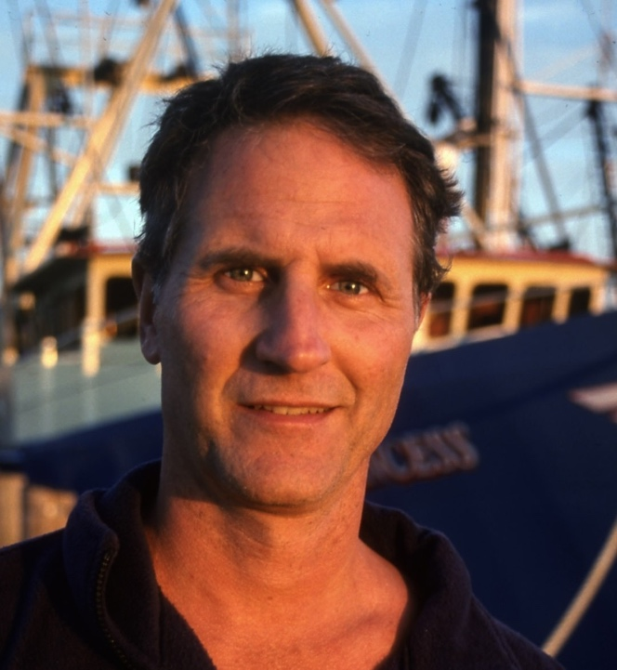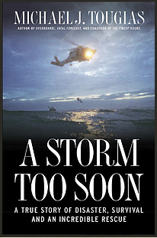

Dear Parents and Guardians,

On ______________________ your child will enjoy Young Audiences’ A Storm Too Soon: A True Story of Survival and A Remarkable Rescue, a performance by NY Times Bestselling Author Michael Tougias, brought to your school by ______________________. Seventy-foot waves batter a tattered life raft 250 miles out to sea in one of the world’s most dangerous places, the Gulf Stream. Hanging onto the raft are three men, a Canadian, a Brit, and their captain, JP DeLutz, a dual citizen of America and France. Meanwhile, four coast guardsmen battling hurricane force winds, head toward the crew in their Jayhawk helicopter, wondering if they themselves can survive their own rescue mission. Tougias tells the story of his book with the backdrop of dramatic photography. After telling the story, he engages students in a discussion of his research and writing process for the book and offers tips for their own projects.

Talk about it! Ask your child about the program. You can use the following open-ended questions to start the conversation:

Tell me about the performance. What was the best part?
What surprised you? How did it make you feel?
What are you still wondering about? How can we learn more about that?

If your child enjoyed this program, we encourage you to reach out about how you can be involved in bringing the arts to schools. Please visit www.yamass.org to learn more about this and other Young Audiences’ Programs.

