

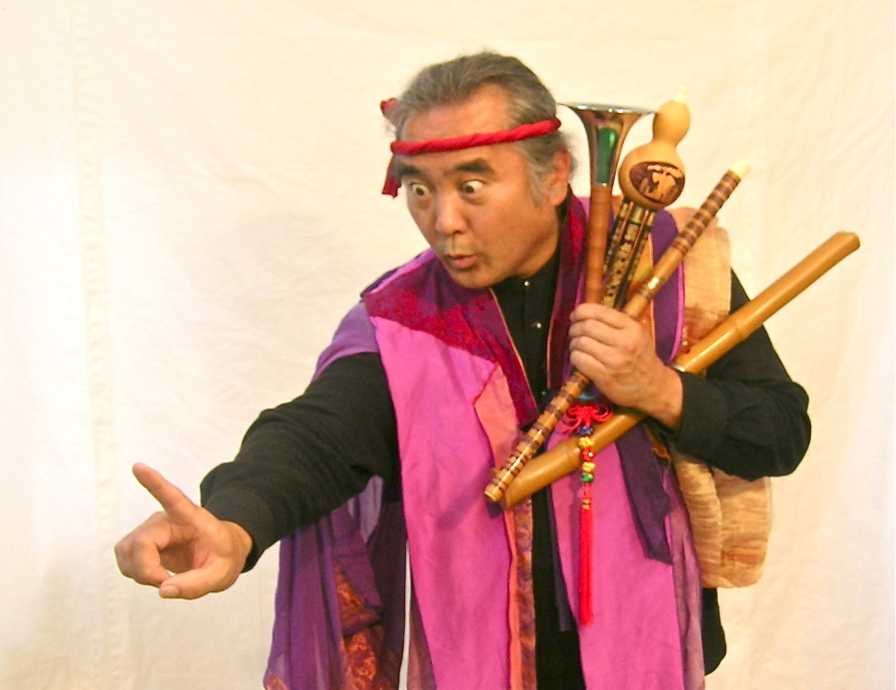

Dear Parents and Guardians,

On ______________________ your child will enjoy Young Audiences’ Eth-Noh-Tec: Asia Fantasia, a performance by storyteller Robert Kikuchi-Yngojo, brought to your school by ______________________. ETH-NOH-TEC is a kinetic storytelling company based in San Francisco that is at once precision choreography, lyrical word-weaving, graceful, playful and poetic. By layering ancient Asian mythologies, folktales and Asian urban legends with Asian American sensibilities, Eth-Noh-Tec has created an exciting new blend of movement-based storytelling.

Talk about it! Ask your child about the program. You can use the following open-ended questions to start the conversation:

Tell me about the performance. What was the best part?
What surprised you? How did it make you feel?
What are you still wondering about? How can we learn more about that?

If your child enjoyed this program, we encourage you to reach out about how you can be involved in bringing the arts to schools. Please visit www.yamass.org to learn more about this and other Young Audiences’ Programs.

