
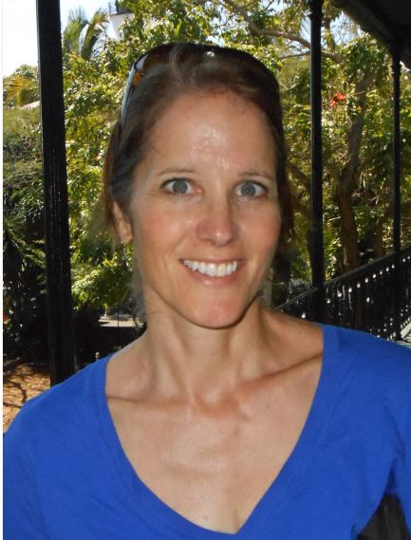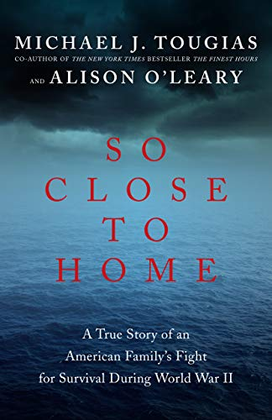

Dear Parents and Guardians,

On ______________________ your child will enjoy Young Audiences’ So Close to Home, a performance by author Alison O’Leary, brought to your school by ______________________. Award-winning author Alison O’Leary presents the true story of men and women pitted against the sea during World War II―an unforgettable portrait of the determination of the human spirit that will challenge your knowledge of the war. Alison describes the challenging post-Depression years of the early 1940s when an average family with two working parents decided to move to South America for a job opportunity, only to be caught in the crosshairs of a German submarine during their return trip.

Talk about it! Ask your child about the program. You can use the following open-ended questions to start the conversation:

Tell me about the performance. What was the best part?
What surprised you? How did it make you feel?
What are you still wondering about? How can we learn more about that?

If your child enjoyed this program, we encourage you to reach out about how you can be involved in bringing the arts to schools. Please visit www.yamass.org to learn more about this and other Young Audiences’ Programs.

