
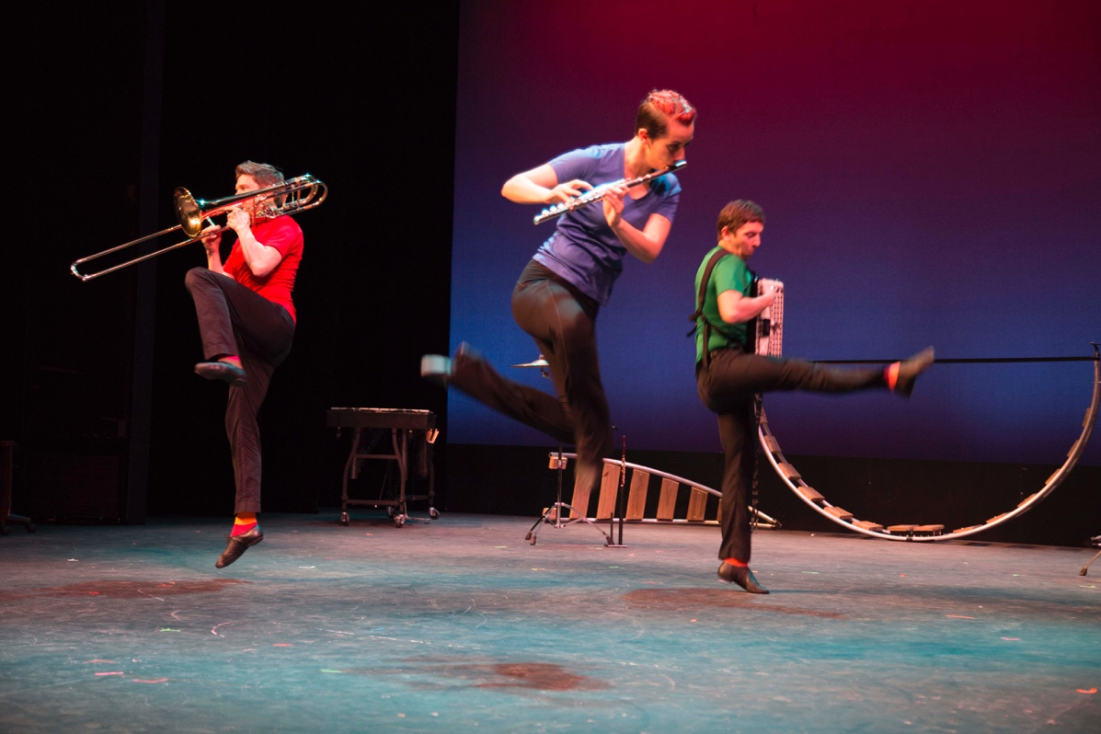

Dear Parents and Guardians,

On ______________ your child will enjoy Young Audiences’ How Music Works: The Science of Sound, a performance hybrid arts ensemble The Fourth Wall, brought to your school by __________________. Using a live oscilloscope, images of wave forms, interactive activities, and (of course) our hybrid arts aesthetic, students learn how vibration, waves, frequency, and amplitude combine with melody, accompaniment and harmony to create music.

Talk about it! Ask your child about the program. You can use the following open-ended questions to start the conversation:

Tell me about the performance. What was the best part?
What surprised you? How did it make you feel?
What are you still wondering about? How can we learn more about that?

If your child enjoyed this program, we encourage you to reach out about how you can be involved in bringing the arts to schools. Please visit www.yamass.org to learn more about this and other Young Audiences’ Programs.

