
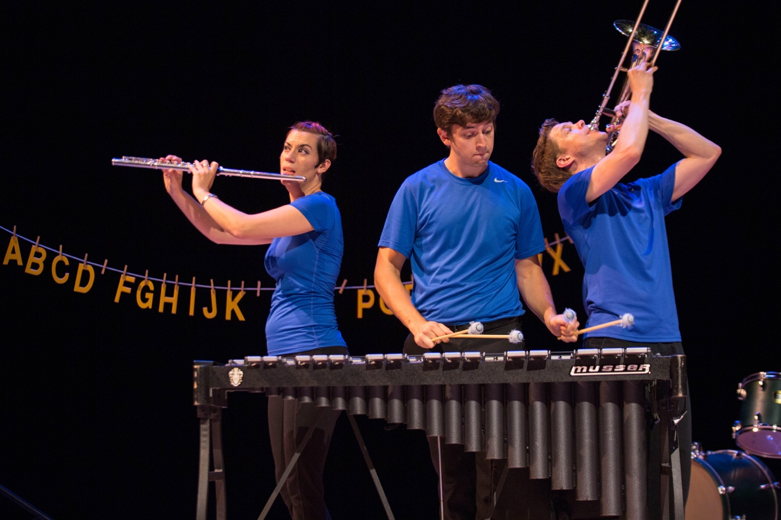

Dear Parents and Guardians,

On ______________________ your child will enjoy Young Audiences’ Fruit Flies Like a Banana, a performance by hybrid arts ensemble The Fourth Wall, brought to your school by _________________. Working at break-neck speed, the multi-talented performers of The Fourth Wall combine music, theater, and dance in this sprint-triathlon variety show. The audience chooses the show order by picking cards from a deck and even determines parameters for some pieces created on the spot. Every performance is unique! As the onstage timer ticks down, The Fourth Wall will blow your mind with tricks, bust your gut with laughter, and maybe even bring a tear to your eye with beautiful music.

Talk about it! Ask your child about the program. You can use the following open-ended questions to start the conversation:

Tell me about the performance. What was the best part?
What surprised you? How did it make you feel?
What are you still wondering about? How can we learn more about that?

If your child enjoyed this program, we encourage you to reach out about how you can be involved in bringing the arts to schools. Please visit www.yamass.org to learn more about this and other Young Audiences’ Programs.

