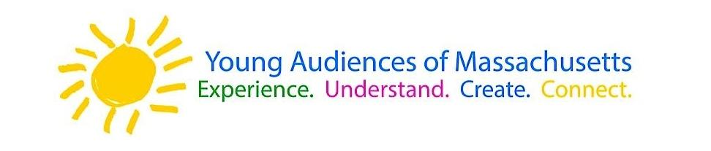
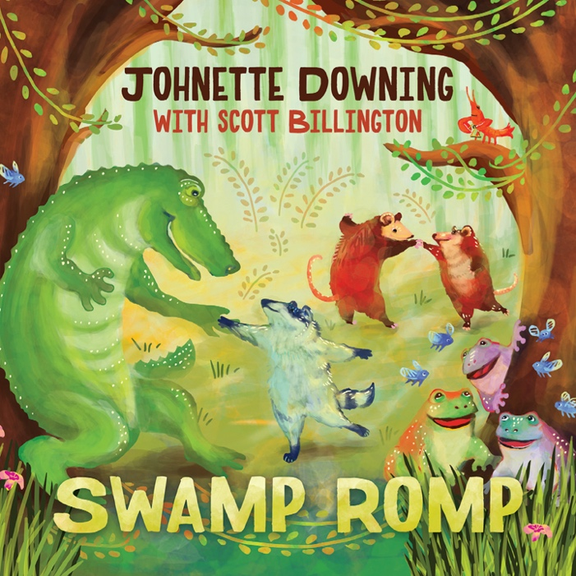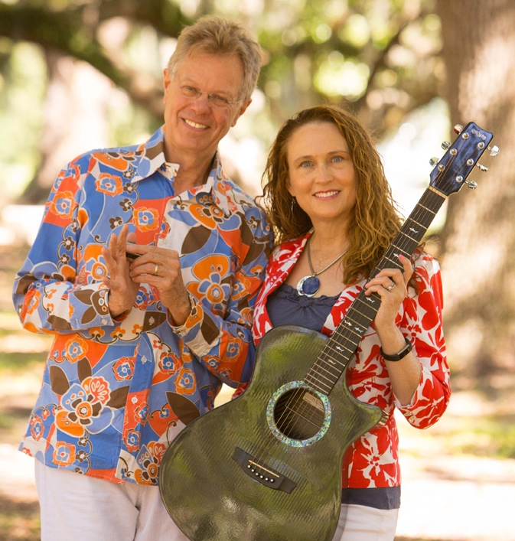

Dear Parents and Guardians,

On ______________________ your child will enjoy Young Audiences’ Swamp Romp, a performance by New Orleans musicians Johnette and Scott, brought to your school by ______________________. Johnette and Scott’s Swamp Romp concert is a rollicking ride through Louisiana roots music from Cajun, zydeco, traditional jazz, Isleño, swamp pop and New Orleans rhythm and blues. Children and families are immersed in Louisiana culture, traditions, cuisine and dance through interactive songs about Mardi Gras king cakes, New Orleans po’ boy sandwiches, the Bamboula rhythm, Isleño oxcarts, and how to spell Mississippi River. Simple words in French and Spanish are introduced, with translations.

Talk about it! Ask your child about the program. You can use the following open-ended questions to start the conversation:

Tell me about the performance. What was the best part?
What surprised you? How did it make you feel?
What are you still wondering about? How can we learn more about that?

If your child enjoyed this program, we encourage you to reach out about how you can be involved in bringing the arts to schools. Please visit www.yamass.org to learn more about this and other Young Audiences’ Programs.

