
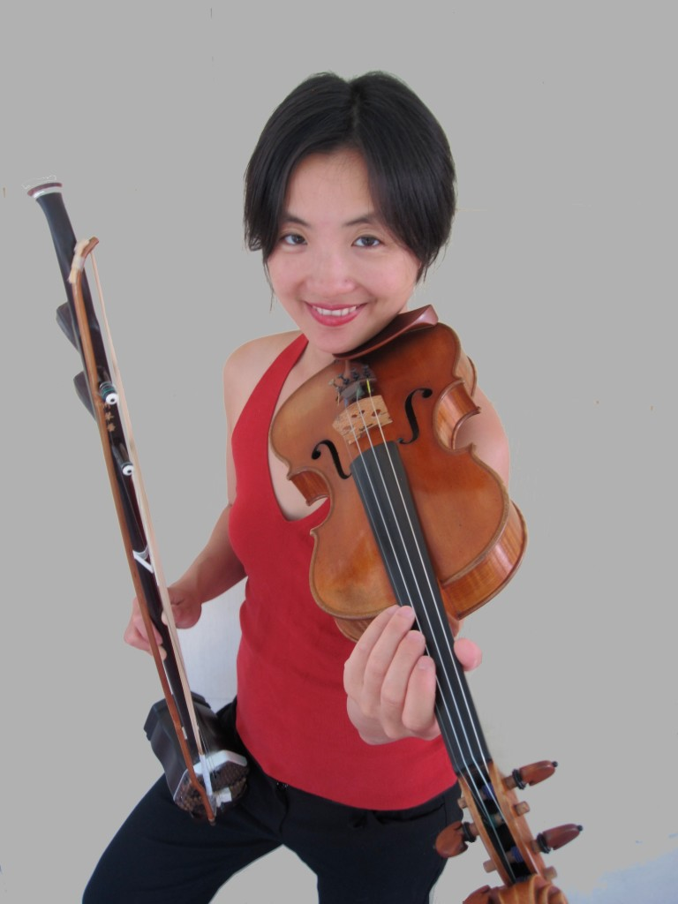

Dear Parents and Guardians,

On ______________________ your child will enjoy Young Audiences’ Exploring China: The “Middle Kingdom” Through Music & Story, a performance by world-class musician Shaw Pong Liu, brought to your school by ______________________. From the grasslands of Mongolia to the high mountain of Yunnan, master musician Shaw Pong Liu takes audiences on a musical journey through historical and contemporary China. Her suitcase packed with languages and musical instruments, Shaw Pong weaves history, geography, the Mandarin language and Chinese folk music in a dynamic exploration of China.

Talk about it! Ask your child about the program. You can use the following open-ended questions to start the conversation:

Tell me about the performance. What was the best part?
What surprised you? How did it make you feel?
What are you still wondering about? How can we learn more about that?

If your child enjoyed this program, we encourage you to reach out about how you can be involved in bringing the arts to schools. Please visit www.yamass.org to learn more about this and other Young Audiences’ Programs.

