
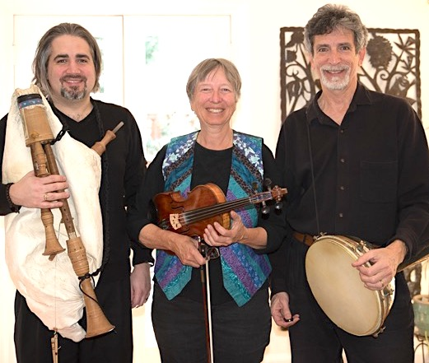

Dear Parents and Guardians,

On ______________________ your child will enjoy Young Audiences’ The Immigrant Experience, a performance by musical ensemble Promised Land, brought to your school by ___________________.
In this interactive music and history program, a talented trio of musicians bring a variety of immigration stories, pictures and folk instruments including the dumbek guitar, jaw harp, tambourine, penny whistle, fiddle, native American flute, tabor, bagpipes, castanets, trombone, harmonica, bodhran and riqq to demonstrate that American culture is woven from a patchwork of sounds and traditions.

Talk about it! Ask your child about the program. You can use the following open-ended questions to start the conversation:

Tell me about the performance. What was the best part?
What surprised you? How did it make you feel?
What are you still wondering about? How can we learn more about that?

If your child enjoyed this program, we encourage you to reach out about how you can be involved in bringing the arts to schools. Please visit www.yamass.org to learn more about this and other Young Audiences’ Programs.

