
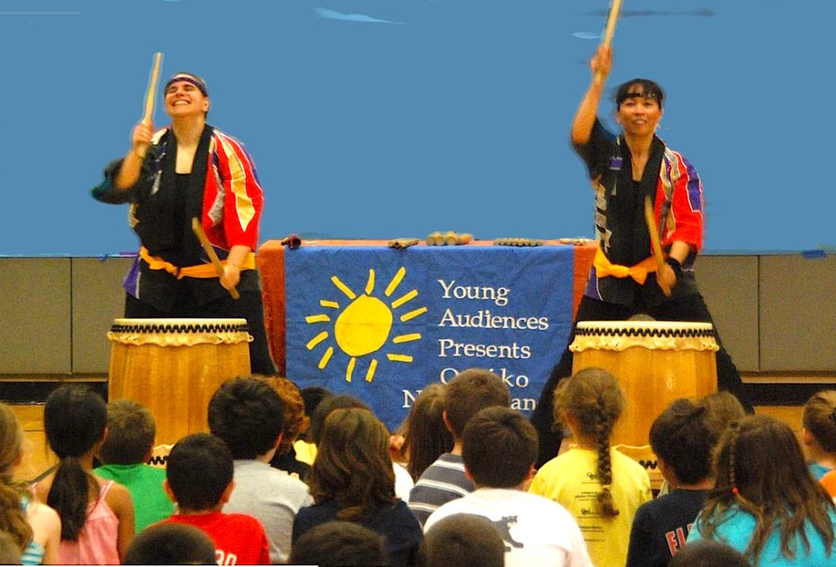

Dear Parents and Guardians,

On ______________________ your child will enjoy Young Audiences’ Taiko Thunder, a performance by Odaiko New England, brought to your school by ______________________. Odaiko New England demonstrates the ancient art form of taiko (Japanese drumming) and its importance in Japanese culture. This energetic and engaging program highlights kumi-daiko (ensemble drumming) and combines traditional taiko rhythms with dynamic movement and rhythms from other musical traditions.

Talk about it! Ask your child about the program. You can use the following open-ended questions to start the conversation:

Tell me about the performance. What was the best part?
What surprised you? How did it make you feel?
What are you still wondering about? How can we learn more about that?

If your child enjoyed this program, we encourage you to reach out about how you can be involved in bringing the arts to schools. Please visit www.yamass.org to learn more about this and other Young Audiences’ Programs.

