
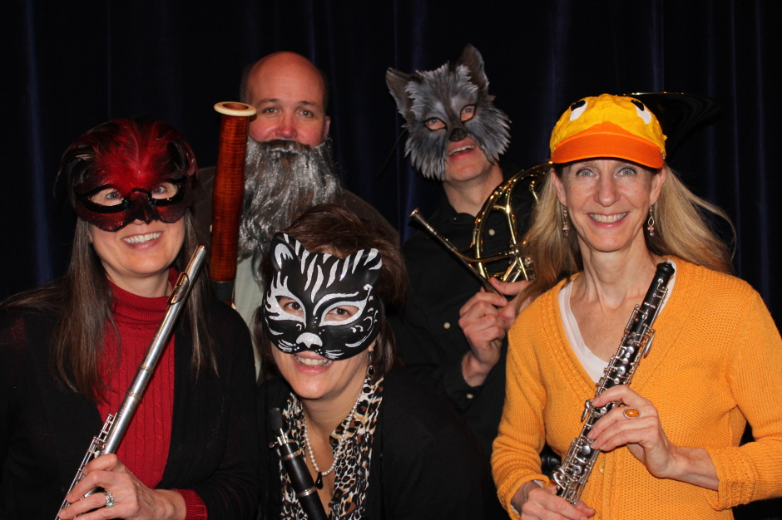

Dear Parents and Guardians,

On ______________________ your child will enjoy Young Audiences’ Peter and the Wolf, a performance by music ensemble North Winds, brought to your school by ______________________. North Winds brings the classic tale and musical composition by Sergei Prokofiev to life. In a fun-filled performance, they highlight the use of character portrayal through the distinct voices of oboe, clarinet, flute and bassoon.

Talk about it! Ask your child about the program. You can use the following open-ended questions to start the conversation:

Tell me about the performance. What was the best part?
What surprised you? How did it make you feel?
What are you still wondering about? How can we learn more about that?

If your child enjoyed this program, we encourage you to reach out about how you can be involved in bringing the arts to schools. Please visit www.yamass.org to learn more about this and other Young Audiences’ Programs.

