
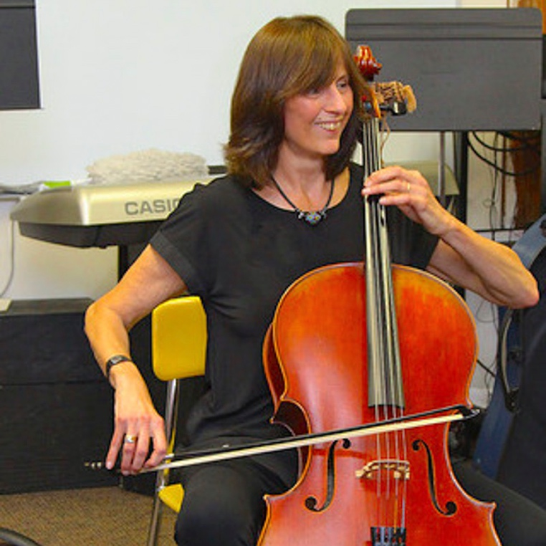

Dear Parents and Guardians,

On ______________________ your child will enjoy Young Audiences’ The Talking Cello, a performance by musician Nancy Hair, brought to your school by ______________________.
This unique classical music program for kids, introduces one classroom at a time to the cello as storyteller, as a tale it is told first with musical accompaniment and then with the cello as the sole narrator. Students also create their own story as a group which is then performed by Nancy and her cello to their delight. During this interactive program, students use finger math, writing, and drawing skills.

Talk about it! Ask your child about the program. You can use the following open-ended questions to start the conversation:

Tell me about the performance. What was the best part?
What surprised you? How did it make you feel?
What are you still wondering about? How can we learn more about that?

If your child enjoyed this program, we encourage you to reach out about how you can be involved in bringing the arts to schools. Please visit www.yamass.org to learn more about this and other Young Audiences’ Programs.

