
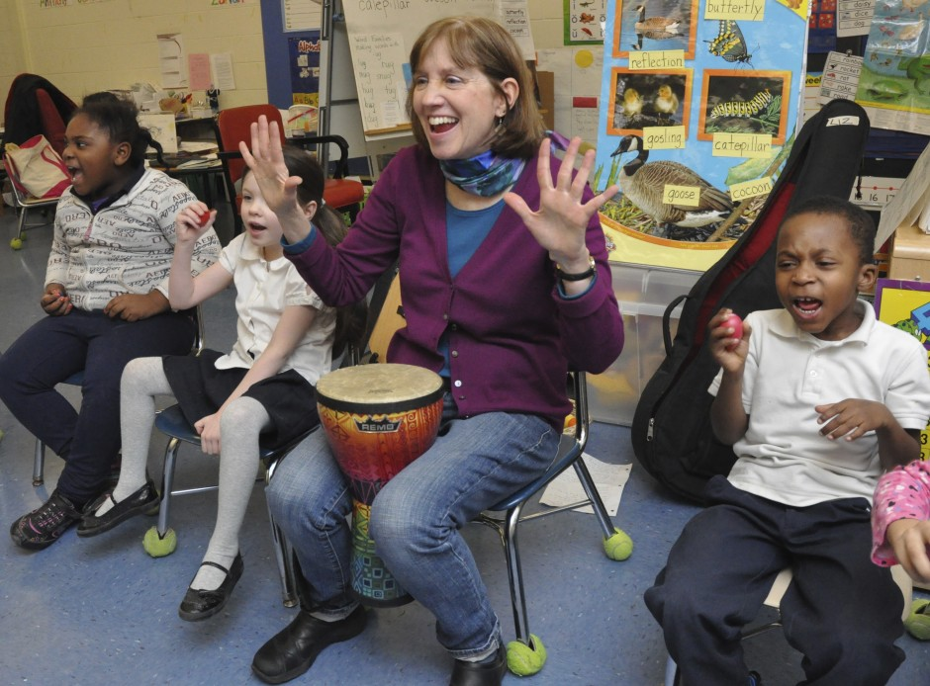

Dear Parents and Guardians,

On ______________________ your child will enjoy Young Audiences’ Do-Re-Mi-A-B-C: Songs for Learning to Read, a performance by musician and songwriter Liz Buchanan, brought to your school by ______________________. In an interactive program tailored to small groups, this seasoned children’s performer gets kids singing and moving with emphasis on basic literacy skills: rhyming, sounding out words, and understanding the elements of stories. Using shakers and other simple percussion instruments, students will play along with Liz and her guitar, while learning about syllables, letter sounds, rhymes and word families.

Talk about it! Ask your child about the program. You can use the following open-ended questions to start the conversation:

Tell me about the performance. What was the best part?
What surprised you? How did it make you feel?
What are you still wondering about? How can we learn more about that?

If your child enjoyed this program, we encourage you to reach out about how you can be involved in bringing the arts to schools. Please visit www.yamass.org to learn more about this and other Young Audiences’ Programs.

