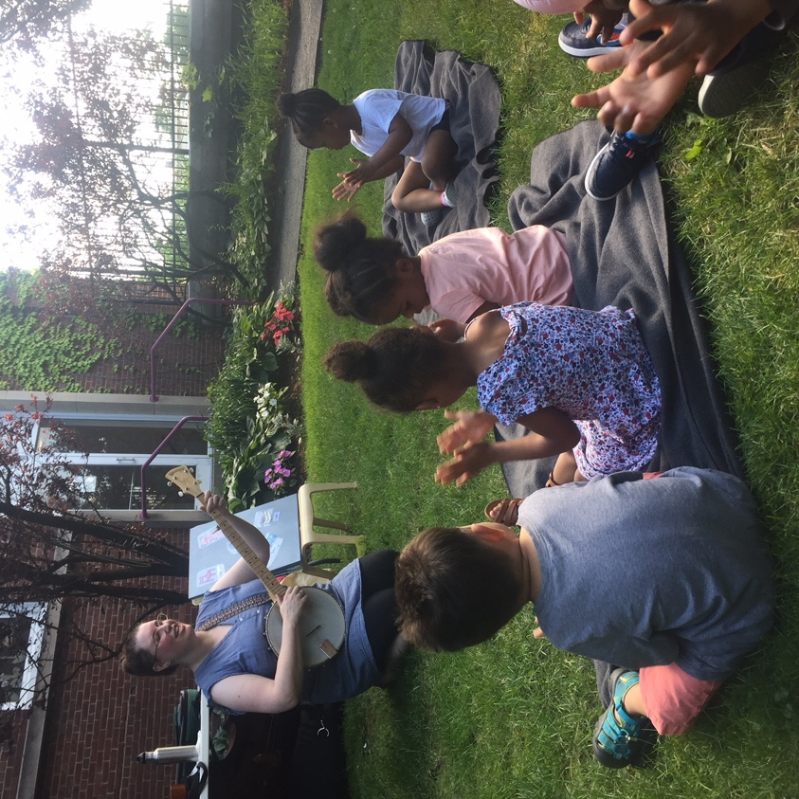

Dear Parents and Guardians,

On ______________________ your child will enjoy Young Audiences’ Coyote’s Song, a performance by acclaimed musician and educator Kirsten Lamb, brought to your school by ___________________. "Coyote’s Song" is a unique introduction to the double bass, voice, and basic musical concepts. Part concert, part storytelling, and part sing-along, the program begins with a demonstration on the double bass, leading to the interactive musical story. Following the story, two basic rhythmic patterns based on the story’s characters are taught and performed by students. The program ends with songs accompanied by banjo, and a question and answer session with students.

Talk about it! Ask your child about the program. You can use the following open-ended questions to start the conversation:

Tell me about the performance. What was the best part?
What surprised you? How did it make you feel?
What are you still wondering about? How can we learn more about that?

If your child enjoyed this program, we encourage you to reach out about how you can be involved in bringing the arts to schools. Please visit www.yamass.org to learn more about this and other Young Audiences’ Programs.

