
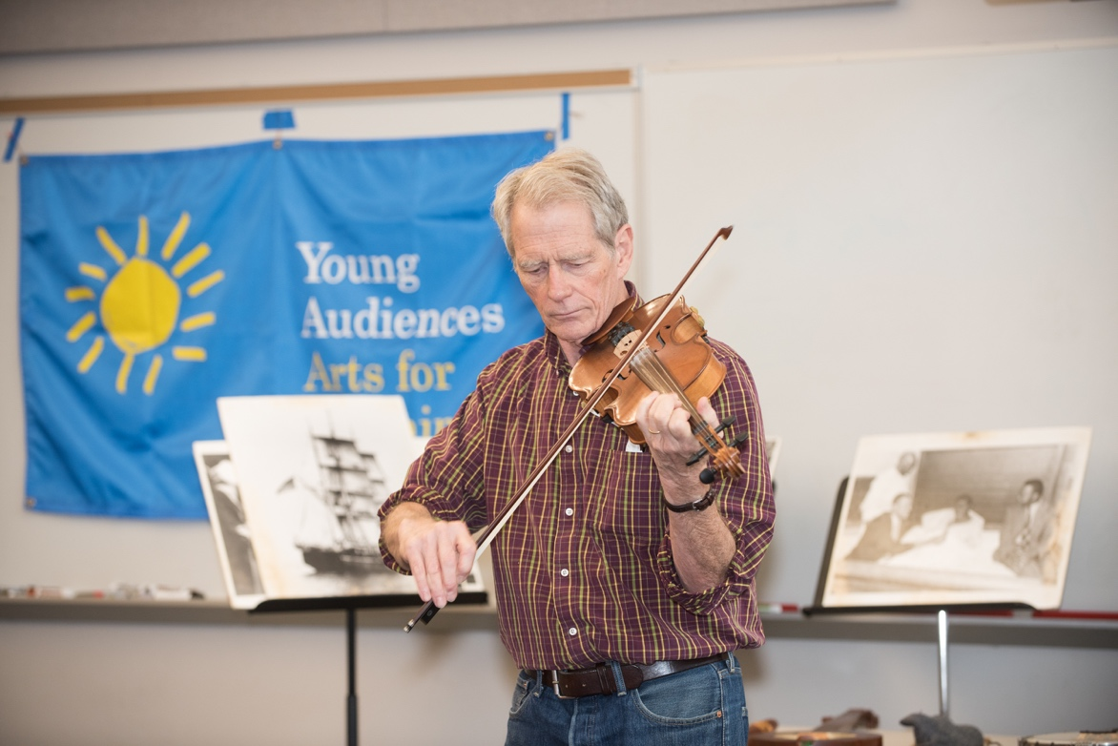

Dear Parents and Guardians,

On ______________________ your child will enjoy Young Audiences’ American Sampler, a performance by American folk musician Jeff Davis, brought to your school by ___________________. With humor, warmth, and scholarship, Jeff invites your students to relive our nation’s heritage through songs of Revolutionary War heroes, Appalachian clogging songs, sailors’ work songs, African-American banjo tunes, Irish fiddle tunes, cowboy ditties, and more! Jeff accompanies himself on an array of instruments, ranging from the humble nose flute to a one-of-a-kind fretless banjo. Students join in on the fun with traditional found instruments, such as bones and spoons.

Talk about it! Ask your child about the program. You can use the following open-ended questions to start the conversation:

Tell me about the performance. What was the best part?
What surprised you? How did it make you feel?
What are you still wondering about? How can we learn more about that?

If your child enjoyed this program, we encourage you to reach out about how you can be involved in bringing the arts to schools. Please visit www.yamass.org to learn more about this and other Young Audiences’ Programs.

