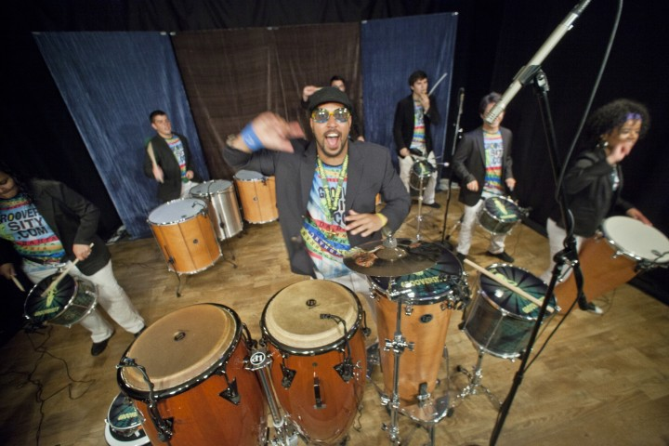

Dear Parents and Guardians,

On ______________________ your child will enjoy Young Audiences’ Brazilian Beats, a performance by Marcus Santos & Grooverstiy, brought to your school by ______________________. In Brazilian Beats, acclaimed percussionist, educator, activist and Grooversity maestro Marcus Santos leads an ensemble of drummers and dancers in a high-energy survey of Brazilian drumming styles springing from his native Bahia—the original capital of Brazil. Students will join in the fun with call-and-response chants and funky dance moves as they are introduced to soul-stirring Afro-Brazilian spirituals, the jazz that street soloists make with instruments as humble as plastic buckets, the thunderous and gleeful drumming of festival marching bands, and the modern sounds of Samba Funk.

Talk about it! Ask your child about the program. You can use the following open-ended questions to start the conversation:

Tell me about the performance. What was the best part?
What surprised you? How did it make you feel?
What are you still wondering about? How can we learn more about that?

If your child enjoyed this program, we encourage you to reach out about how you can be involved in bringing the arts to schools. Please visit www.yamass.org to learn more about this and other Young Audiences’ Programs.

