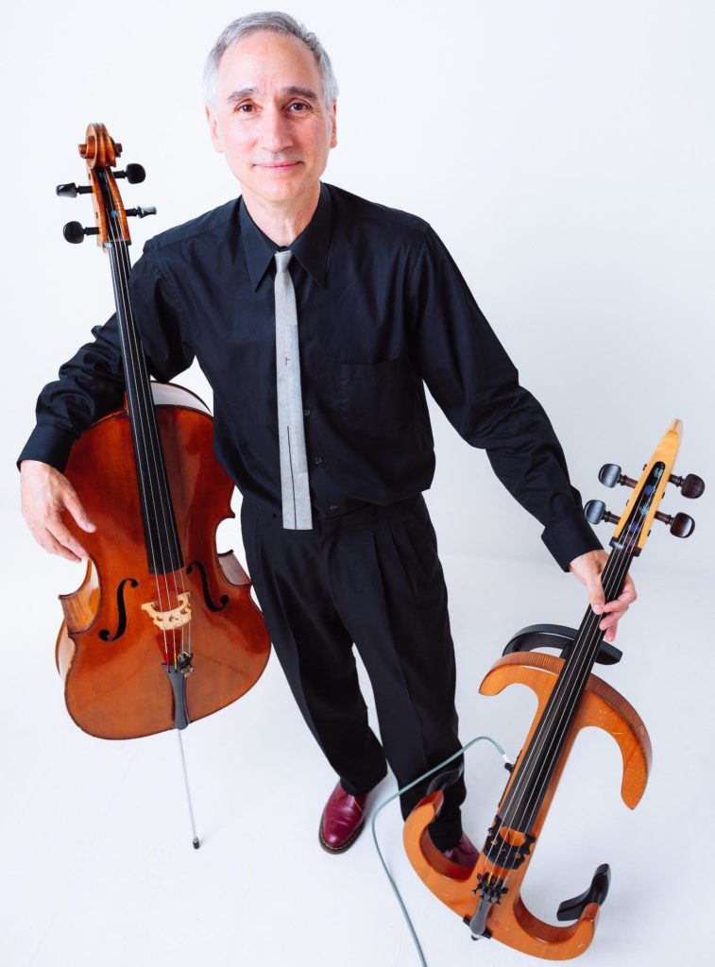

Dear Parents and Guardians,

On ______________________ your child will enjoy Young Audiences’ Sound Science, a performance by musician Gideon Freudmann, brought to your school by ______________________. Sound Science is a S.T.E.A.M. program exploring both music and the scientific properties of sound. Demonstrating the tonal qualities of both the acoustic and electric cellos, Gideon explains the mathematical aspects of music such as how music is divided into beats, measures and phrases, and acoustic qualities including sound vibrations, pitch, and timbre. Using the electric cello and real-time digital effects, he shows how notes can be echoed, repeated, distorted, and augmented in many exciting and unexpected ways.

Talk about it! Ask your child about the program. You can use the following open-ended questions to start the conversation:

Tell me about the performance. What was the best part?
What surprised you? How did it make you feel?
What are you still wondering about? How can we learn more about that?

If your child enjoyed this program, we encourage you to reach out about how you can be involved in bringing the arts to schools. Please visit www.yamass.org to learn more about this and other Young Audiences’ Programs.

