
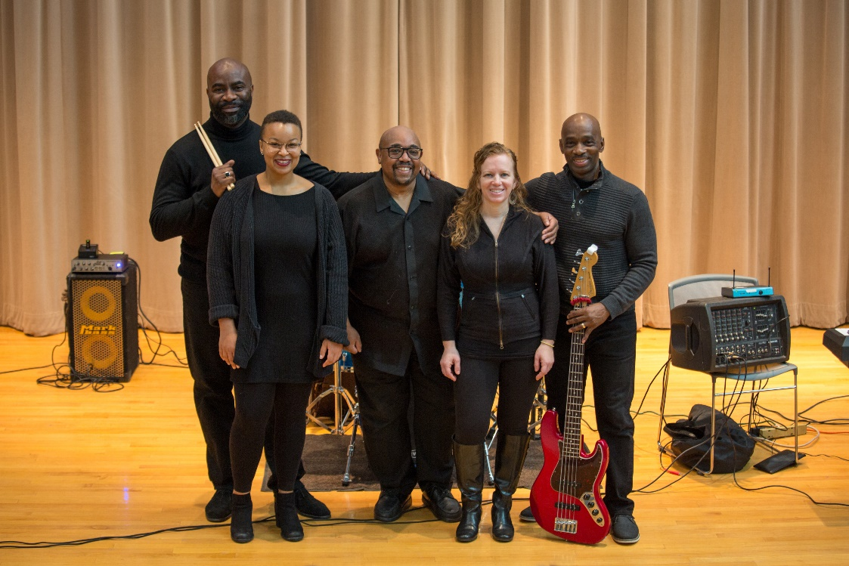

Dear Parents and Guardians,

On ______________________ your child will enjoy Young Audiences’ Clap Your Hands, a performance by music ensemble George Russel, Jr. & Co, brought to your school by ______________________. African-American music (spirituals, folk-blues, and gospel music) has profoundly influenced both musical and political movements throughout our nation’s history. Clap Your Hands explores the rise and changing roles of music in the African-American community: as a mental release during trying times, a vehicle for communication in the Underground Railroad, and a “common ground” during the Civil Rights Movement.

Talk about it! Ask your child about the program. You can use the following open-ended questions to start the conversation:

Tell me about the performance. What was the best part?
What surprised you? How did it make you feel?
What are you still wondering about? How can we learn more about that?

If your child enjoyed this program, we encourage you to reach out about how you can be involved in bringing the arts to schools. Please visit www.yamass.org to learn more about this and other Young Audiences’ Programs.

