

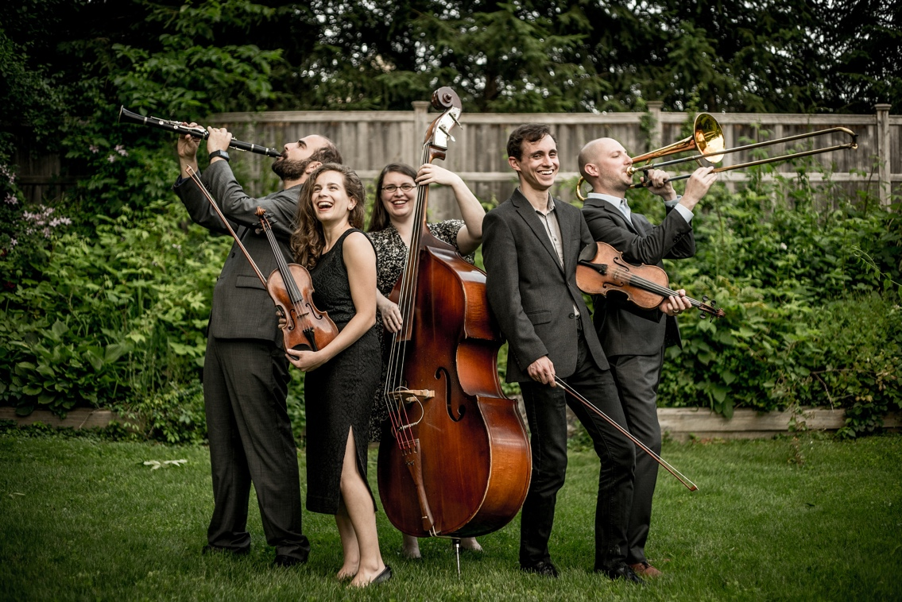

Dear Parents and Guardians,

On ______________________ your child will enjoy Young Audiences’ Exploring Klezmer: Ashkenazi Music and Songs, a performance by Ezekiel’s Wheels Klezmer Band, brought to your school by ______________________. This fun, upbeat, and interactive performance program introduces klezmer music, the Yiddish language, and instruments from three different instrument families. Students will have fun learning about different musical instruments as they move and sing along to a lively set of traditional tunes played on clarinet, violin, trombone, and double bass. They will also learn about klezmer music and its significance in secular Ashkenazi Jewish culture both in Eastern Europe and in the United States as they define popular Yiddish words and sing along to songs with Yiddish lyrics.

Talk about it! Ask your child about the program. You can use the following open-ended questions to start the conversation:

Tell me about the performance. What was the best part?
What surprised you? How did it make you feel?
What are you still wondering about? How can we learn more about that?

If your child enjoyed this program, we encourage you to reach out about how you can be involved in bringing the arts to schools. Please visit www.yamass.org to learn more about this and other Young Audiences’ Programs.

