
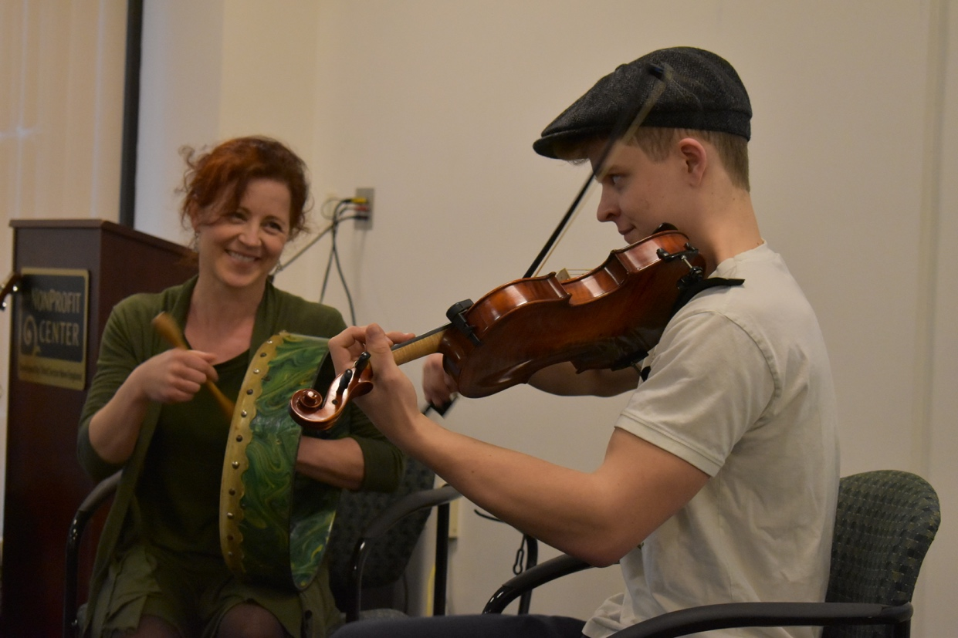

Dear Parents and Guardians,

On ______________________ your child will enjoy Young Audiences’ The Irish in Boston, a performance by Irish Music ensemble Celtic Bells, brought to your school by ____________________. With fiddle, bodhran (Irish drum), banjo, flute, guitar, and bagpipes, Nancy and Calum Bell tell the story of Irish immigrants in Boston, weaving in their songs and poems of work, humor, protest, longing for home, and longing to feel at home in the New World. In addition to providing a rich connection to history curriculum, this program serves as a starting point for meaningful discussions on culture, race, prejudice, and immigration.

Talk about it! Ask your child about the program. You can use the following open-ended questions to start the conversation:

Tell me about the performance. What was the best part?
What surprised you? How did it make you feel?
What are you still wondering about? How can we learn more about that?

If your child enjoyed this program, we encourage you to reach out about how you can be involved in bringing the arts to schools. Please visit www.yamass.org to learn more about this and other Young Audiences’ Programs.

