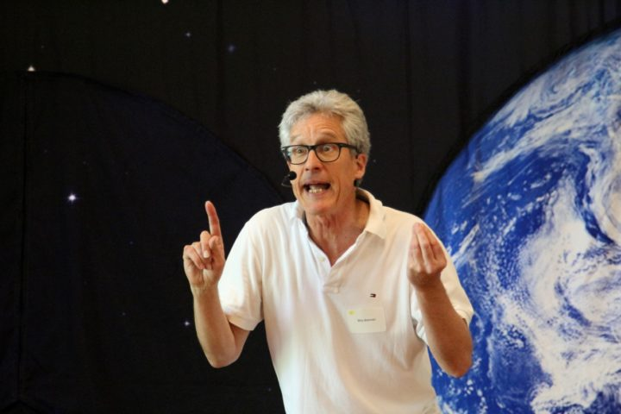

Dear Parents and Guardians,

On ______________________ your child will enjoy Young Audiences’ Weather, Climate, Let’s Define It!, a performance by Natural Science Song and Dance Man Billy B, brought to your school by ______________________. Billy B leads his audience through a song and dance exploration of the differences between weather and climate, the structure and benefits of the atmosphere, and how it all supports the amazing diversity of plant and animal life on our beautiful planet. For older students, Billy introduces the concepts, and science of, the human impact on the atmosphere/climate.

Talk about it! Ask your child about the program. You can use the following open-ended questions to start the conversation:

Tell me about the performance. What was the best part?
What surprised you? How did it make you feel?
What are you still wondering about? How can we learn more about that?

If your child enjoyed this program, we encourage you to reach out about how you can be involved in bringing the arts to schools. Please visit www.yamass.org to learn more about this and other Young Audiences’ Programs.

