
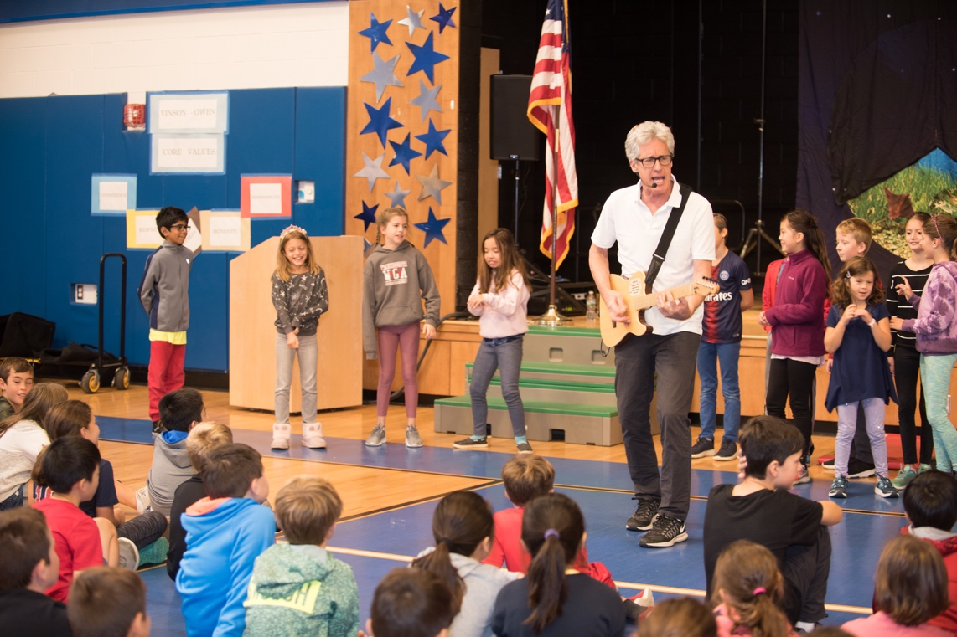

Dear Parents and Guardians,

On ______________________ your child will enjoy Young Audiences’ Ways of the Bay, a performance by the Natural Science Song and Dance Man Billy B, brought to your school by __________________. In Ways of the Bay, Billy B.’s introductory song illustrates how water running off a roof into a drain spout will eventually end up in the local watershed. All of the water from the streets that flows into storm drains or ditches also eventually flows into the closest creek or river. Through song, Billy B. emphasizes that there can be millions of people living within the watershed of a typical bay. Billy also introduces the concepts of excess algae, runoff, oxygen loss in the water, estuary, brackish water, nutrients, decomposers, and plankton. Billy ends his program by talking about a bay’s airshed, energy conservation, and how we can all help to keep the bay healthy by saving energy and planting trees.

Talk about it! Ask your child about the program. You can use the following open-ended questions to start the conversation:

Tell me about the performance. What was the best part?
What surprised you? How did it make you feel?
What are you still wondering about? How can we learn more about that?

If your child enjoyed this program, we encourage you to reach out about how you can be involved in bringing the arts to schools. Please visit www.yamass.org to learn more about this and other Young Audiences’ Programs.

