
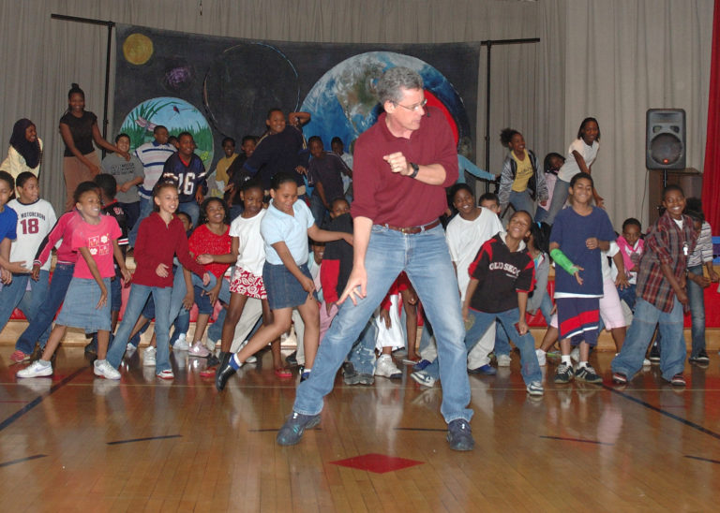

Dear Parents and Guardians,

On ______________________ your child will enjoy Young Audiences’ Nature in the City, a performance by the Natural Science Song and Dance Man Billy B, brought to your school by ______________________. Billy B. examines “urban ecology” in this funny musical introduction to the interaction of plants, animals, humans, and the environment in metropolitan areas. Nature in the City examines the neighborhood ecosystem through song and dance as Billy encourages his audiences to become stewards of the planet.

Talk about it! Ask your child about the program. You can use the following open-ended questions to start the conversation:

Tell me about the performance. What was the best part?
What surprised you? How did it make you feel?
What are you still wondering about? How can we learn more about that?

If your child enjoyed this program, we encourage you to reach out about how you can be involved in bringing the arts to schools. Please visit www.yamass.org to learn more about this and other Young Audiences’ Programs.

