
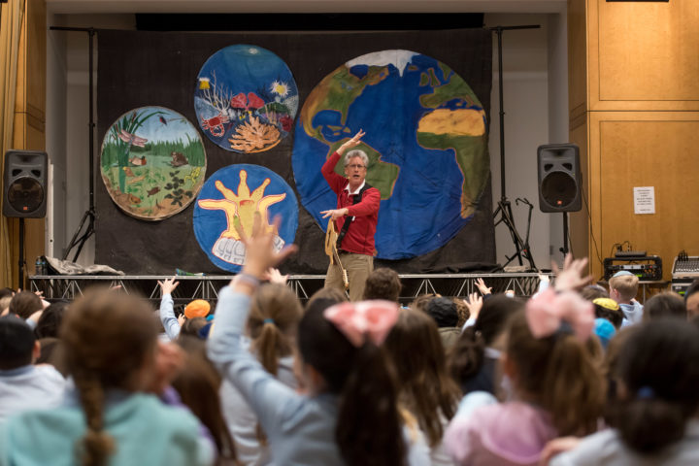

Dear Parents and Guardians,

On ______________________ your child will enjoy Young Audiences’ Bio, Bio, Biodiversity, a performance by the Natural Science Song and Dance Man Billy B, brought to your school by ______________________. Billy B. uses science, humor, music, dance, and audience participation to introduce the wonder of our earth’s biodiversity, why it is declining, and how we can help to protect it. Billy B. hopes to educate people of all ages about biodiversity by introducing issues such as pollution, deforestation, and overfishing and how other human behaviors affect the biodiversity of our earth.

Talk about it! Ask your child about the program. You can use the following open-ended questions to start the conversation:

Tell me about the performance. What was the best part?
What surprised you? How did it make you feel?
What are you still wondering about? How can we learn more about that?

If your child enjoyed this program, we encourage you to reach out about how you can be involved in bringing the arts to schools. Please visit www.yamass.org to learn more about this and other Young Audiences’ Programs.

