
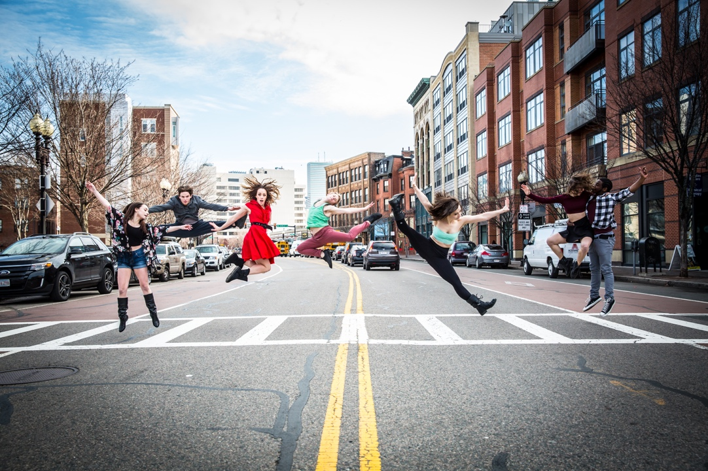

Dear Parents and Guardians,

On ______________________ your child will enjoy Young Audiences’ Dancing In Each Other’s Shoes, a performance by contemporary dance company Urbanity Dance, brought to your school by ________. Drawing from the techniques and traditions of various dance styles including classical ballet, modern, hip hop, and West African, Urbanity dance artists use contemporary dance to communicate a story of empathy, a story of partnership, and a story of emotion. In Dancing in Each Other’s Shoes, Urbanity dance artists and the students embark together on a unique dance exploration of compassion, kindness, and respect. This fresh and highly interactive performance celebrates diversity and encourages community. Students will ultimately be inspired and empowered to utilize lessons of self-expression and acceptance in all aspects of their lives.

Talk about it! Ask your child about the program. You can use the following open-ended questions to start the conversation:

Tell me about the performance. What was the best part?
What surprised you? How did it make you feel?
What are you still wondering about? How can we learn more about that?

If your child enjoyed this program, we encourage you to reach out about how you can be involved in bringing the arts to schools. Please visit www.yamass.org to learn more about this and other Young Audiences’ Programs.

