
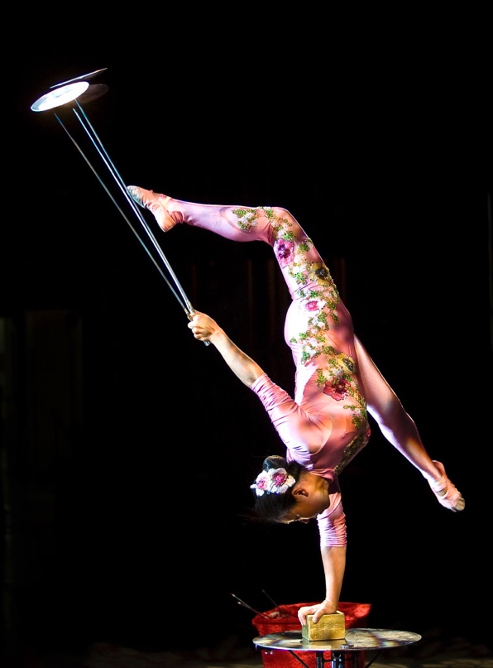

Dear Parents and Guardians,

On ______________________ your child will enjoy Young Audiences’ Traditions of Chinese Acrobatics, a performance by acrobat Li Liu, brought to your school by ___________________. Your child will witness astounding feats of traditional Chinese acrobatics. Students will get a glimpse of Chinese culture and learn phrases in Li Liu’s native Mandarin, and learn the historical significance of traditional lion and dragon dances. Li encourages students to think about what it might have been like to grow up in a different time and place, and what can be accomplished through disciplined training.

Talk about it! Ask your child about the program. You can use the following open-ended questions to start the conversation:

Tell me about the performance. What was the best part?
What surprised you? How did it make you feel?
What are you still wondering about? How can we learn more about that?

If your child enjoyed this program, we encourage you to reach out about how you can be involved in bringing the arts to schools. Please visit www.yamass.org to learn more about this and other Young Audiences’ Programs.

