
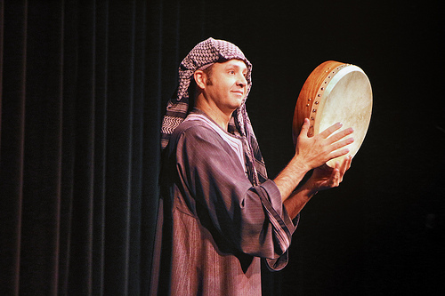

Dear Parents and Guardians,

On ______________________ your child will enjoy Young Audiences’ Arabiqa, a performance by Egyptian-American dancers and musician Karim Nagi, brought to your school by _________________. Karim Nagi helps to introduce students to Arab dance and Arab music in a high-energy performance featuring exciting traditional dances, and soulful folk music played on a variety of traditional instruments. Karim uses authentic costumes, maps, Arabic language, lots of audience participation, and humor, as he enlightens his audience about a captivating world beyond the headlines. Students will clap unique rhythms, dance, and celebrate as they learn about these ancient cultural traditions.

Talk about it! Ask your child about the program. You can use the following open-ended questions to start the conversation:

Tell me about the performance. What was the best part?
What surprised you? How did it make you feel?
What are you still wondering about? How can we learn more about that?

If your child enjoyed this program, we encourage you to reach out about how you can be involved in bringing the arts to schools. Please visit www.yamass.org to learn more about this and other Young Audiences’ Programs.

