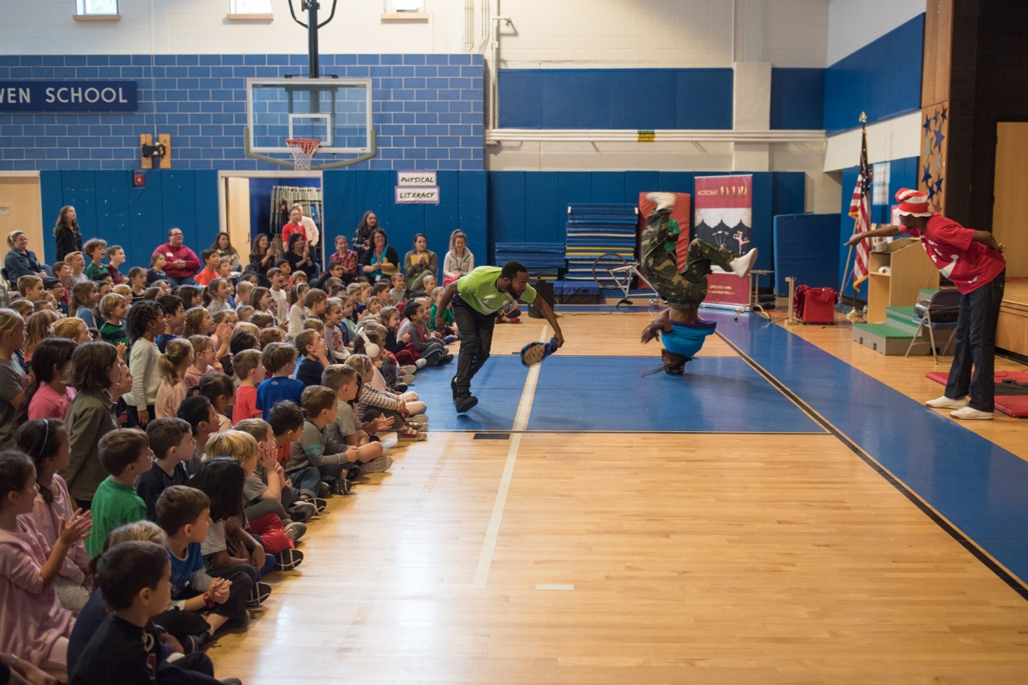

Dear Parents and Guardians,

On ______________________ your child will enjoy Young Audiences’ Become Your Dreams: History of Hip Hop Dance, a performance by Hip Hop dance company Illstyle and Peace, brought to your school by ______________________. Become Your Dreams celebrates the art and movement of hip hop and includes a funky blend of locking, breaking, popping, tap and house dancing, vocal percussions, D.J.ing, and modern and traditional dance forms. An emphasis is placed on the similarity of some hip hop moves to those found in ballet, modern and traditional dance forms.

Talk about it! Ask your child about the program. You can use the following open-ended questions to start the conversation:

Tell me about the performance. What was the best part?
What surprised you? How did it make you feel?
What are you still wondering about? How can we learn more about that?

If your child enjoyed this program, we encourage you to reach out about how you can be involved in bringing the arts to schools. Please visit www.yamass.org to learn more about this and other Young Audiences’ Programs.

