
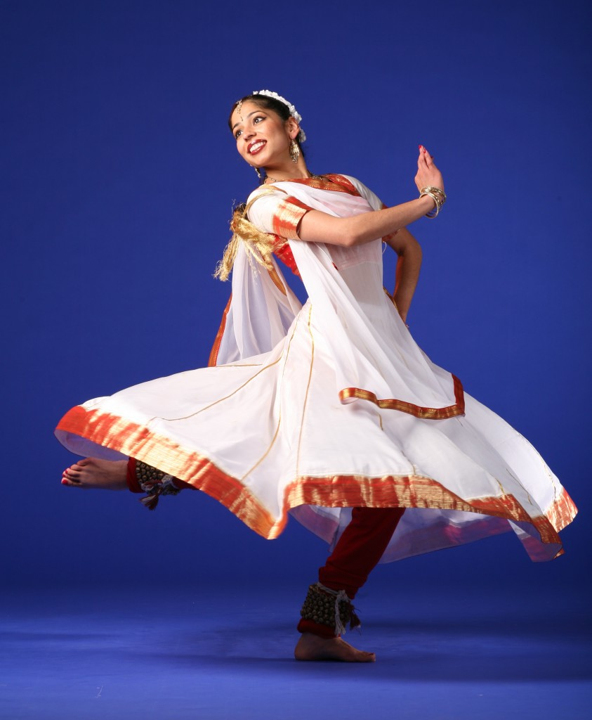

Dear Parents and Guardians,

On ______________________ your child will enjoy Young Audiences’ Kathak Dance of North India, a performance by dancers from Chhandika Kathak Dance, brought to your school by ______________________. The ancient art of Kathak, which takes its name from the Sanskrit word for “story”, is one of the eight forms of classical Indian dance. Kathak dancers use swift and precise footwork and graceful gestures to tell traditional Indian stories. This performance will engage students through movement, music, and math, as students will learn to count out complex poly-rhythms to help the dancer keep time.

Talk about it! Ask your child about the program. You can use the following open-ended questions to start the conversation:

Tell me about the performance. What was the best part?
What surprised you? How did it make you feel?
What are you still wondering about? How can we learn more about that?

If your child enjoyed this program, we encourage you to reach out about how you can be involved in bringing the arts to schools. Please visit www.yamass.org to learn more about this and other Young Audiences’ Programs.

