
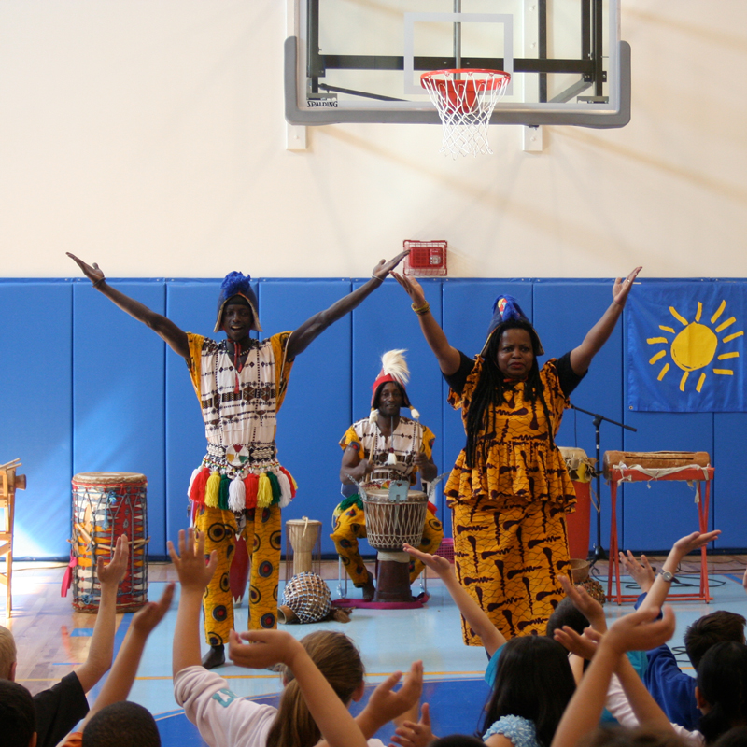

Dear Parents and Guardians,

On ______________________ your child will enjoy Young Audiences’ Wongai! Rhythms of West Africa, Brazil & the Caribbean, a performance by Bamidele Dancers and Drummers, brought to your school by ______________________. Discover celebratory West African dances and their adaptations in Brazilian and Caribbean cultures, set to the rhythms of African drumming in an interactive performance that is guaranteed to bring all ages to their feet. This program features authentic costumes and instruments and can be adapted to include narration on African art, culture, and history.

Talk about it! Ask your child about the program. You can use the following open-ended questions to start the conversation:

Tell me about the performance. What was the best part?
What surprised you? How did it make you feel?
What are you still wondering about? How can we learn more about that?

If your child enjoyed this program, we encourage you to reach out about how you can be involved in bringing the arts to schools. Please visit www.yamass.org to learn more about this and other Young Audiences’ Programs.

